Chapter 11 - Data is the New Oil

### 📘 React Key Topics

* HOC
* Controlled Component
* Uncontrolled Component
* Lifting the state up
* Build your own Accordion
* React dev tools
* Context API

**What is a Higher-Order Component (HOC)?**

A Higher-Order Component (HOC) is a regular JavaScript function that takes an existing component as input, enhances it by adding additional functionality, and returns a new, modified component. It does not change the core functionality of the original component. Instead, it wraps the component to extend its behavior. This is why HOCs are often referred to as pure functions.

In the following example, we have created a higher-order component called withVegLabel, which takes the RestaurantCard component as input and returns an enhanced version of it.

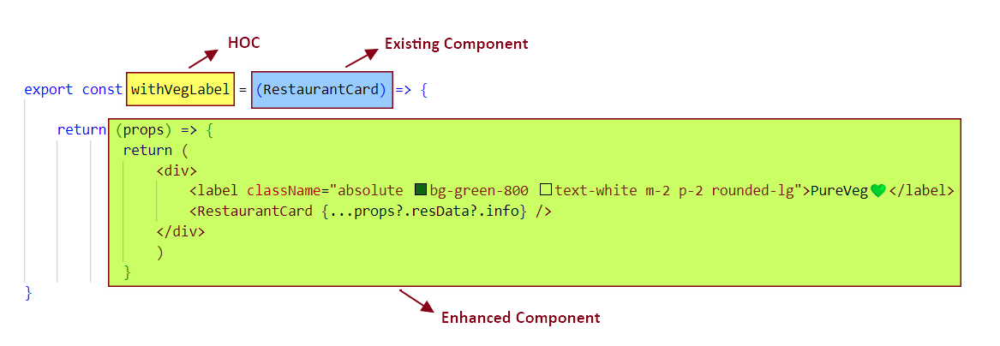

The enhanced component adds a "PureVeg" label and receives data as props from the parent. These props are then passed down to the original RestaurantCard component. Since withVegLabel does not modify the original component's logic, it is considered a pure function.

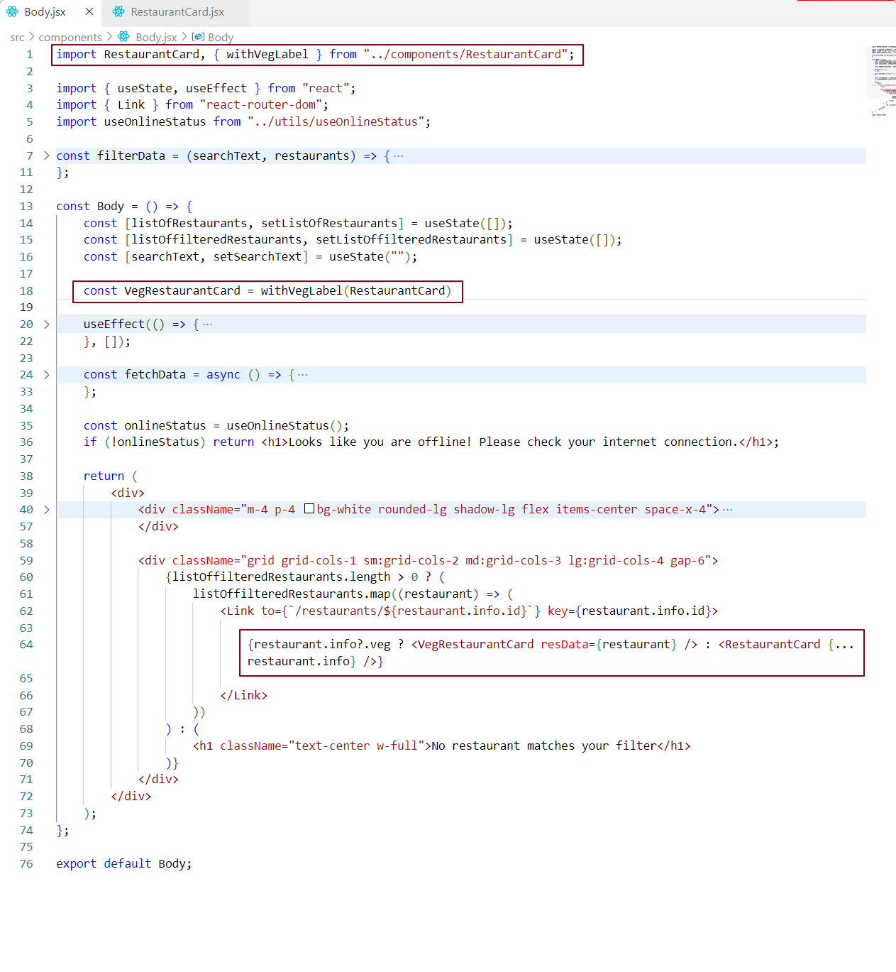

In this code snippet, at **line 18,** we invoke the HOC withVegLabel, passing RestaurantCard as an argument. This returns an **enhanced component**, which is essentially a function that accepts a single parameter - props (see Figure 1 for the structure of the enhanced component).

The returned enhanced component is then assigned to VegRestaurantCard.

At **line 64**, we render VegRestaurantCard conditionally:

* If the restaurant is vegetarian, we display the **enhanced** card component (VegRestaurantCard).
* Otherwise, we render the standard RestaurantCard component.

When we say **"display the enhanced veg component,"** we mean rendering the VegRestaurantCard component. While rendering this enhanced component, we pass the required props using resData.

**Note:** Passing props to the enhanced component (VegRestaurantCard) is the same as passing props to the **function returned by the HOC.**

The UI now appears as shown below:

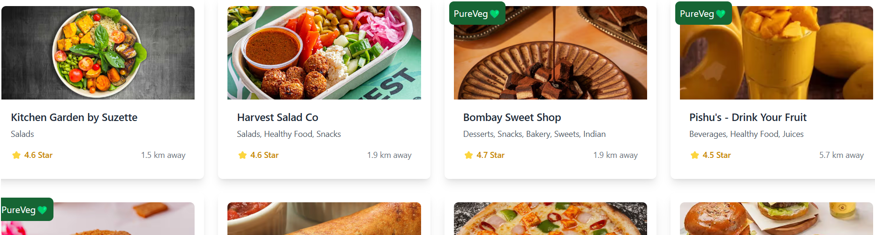

* PureVeg Cards → *Rendered using the Enhanced Component (VegRestaurantCard)*
* Other Cards → *Rendered using the Existing Component (RestaurantCard)*

Every React application consists of **two main layers**:the **UI layer** and the **data layer**. The **UI layer** is powered by the **data layer**.

* In the **data layer**, we manage application data using **props, state, local variables, context,** and **hooks.**
* In the **UI layer,** we manage **JSX**, which controls the **look and feel** of the application.

Accordion Template

Let's begin by adding the **accordion layout** to our project. Before implementing its interactive functionality, we'll first focus on designing the **accordion structure** and its **appearance**.

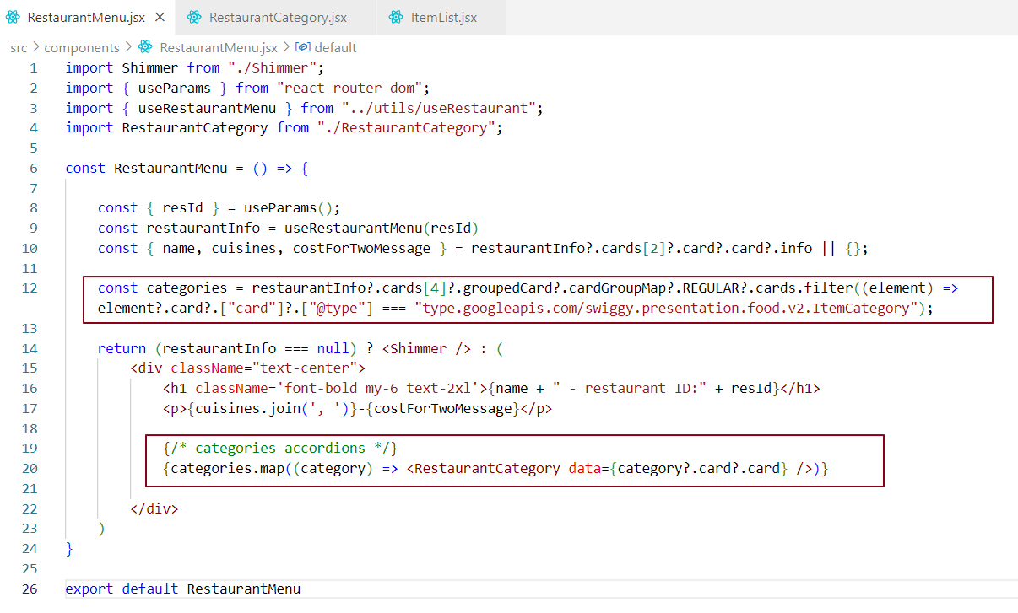

In line 12, we are fetching the list of categories, which will be used to display the accordion structure. The categoryheader will serve as the accordionheader, and the categorycontent will be the accordioncontent.

To achieve this, we need to call the RestaurantCategory component for each category. This ensures that each category has its own header and content. We are rendering the RestaurantCategory components on line20.

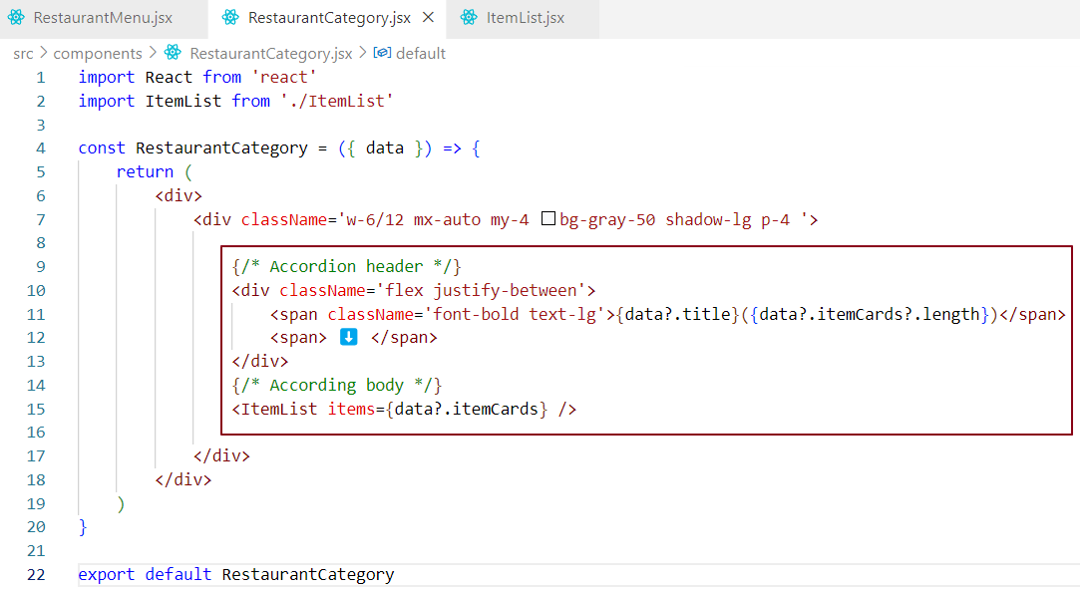

In the RestaurantCategory component, we are constructing the **accordion structure**. The **category title**, along with the number of items in that category, is displayed as the **accordion header**. The ItemList component, which contains the list of items for each category, is used as the **accordion body** for each category.

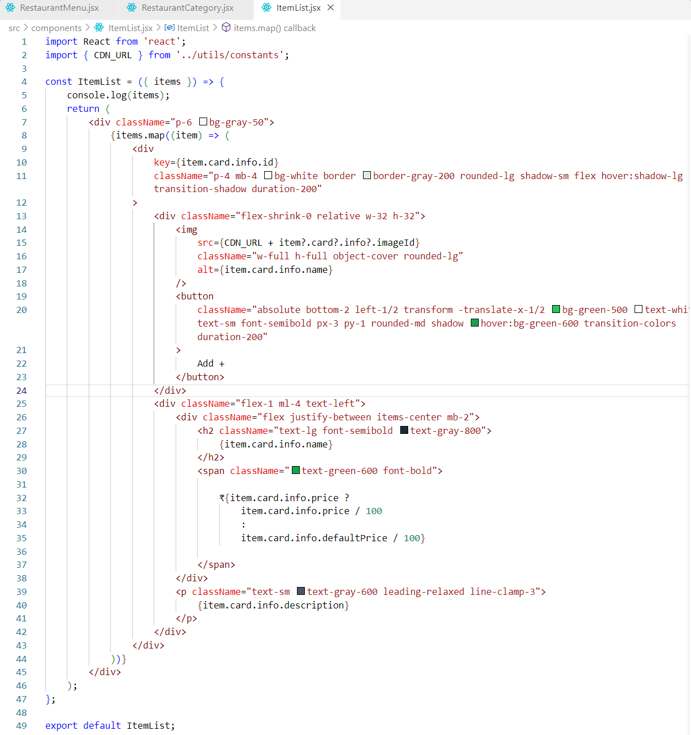

The ItemList component renders a list of items, where each item includes an image, name, price, and description. It maps over the items array and displays each item in a styled card with a hover effect.

The image is displayed in a square container, with an "Add +" button positioned at the bottom centre.

The item name and price are displayed in a row, with the price formatted as currency (by dividing it by 100). If the price is unavailable, the component falls back to a default price.

The description is shown below the name and price, limited to three lines, with an ellipsis if the text exceeds this limit.

Each itemcard is styled with roundedcorners, a subtle shadow, and a clean layout using TailwindCSSutilities, ensuring responsiveness and interactivity with hover effects.

We have already implemented the display of multiple categories in the accordion structure. However, I’ve included a screenshot showing just one category header and its content for documentation purposes. This is to illustrate the layout as it currently appears, but the final implementation will cover all categories in the app.

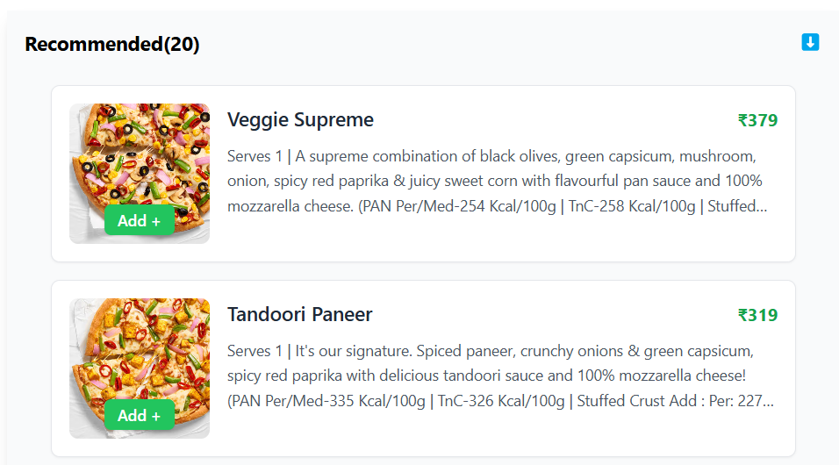

Now that we’ve established the accordion structure, let’s proceed with adding functionality to it.

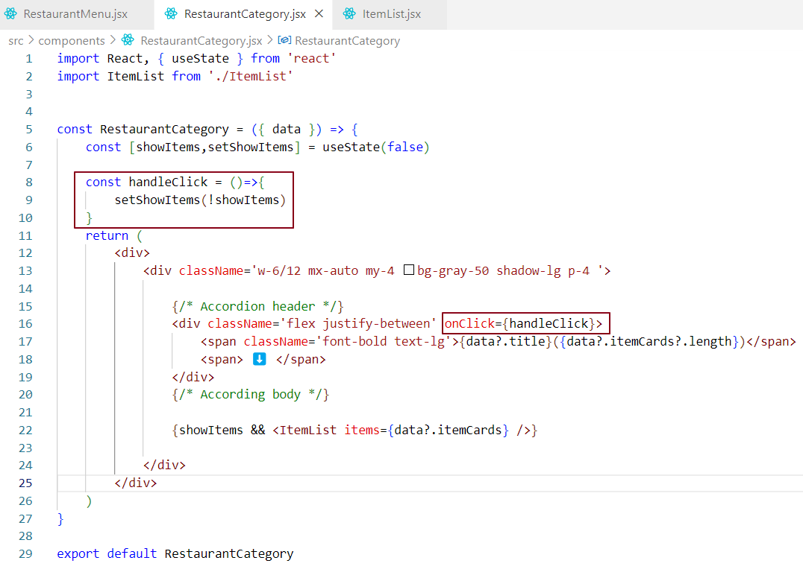

We have added the toggle accordion functionality. When the RestaurantMenu component is loaded, it renders multiple RestaurantCategory components, each representing a category accordion. Initially, all category accordions are collapsed because the showItems state for each category is set to false. This means the content (ItemList) of the accordion is not displayed when showItems is false.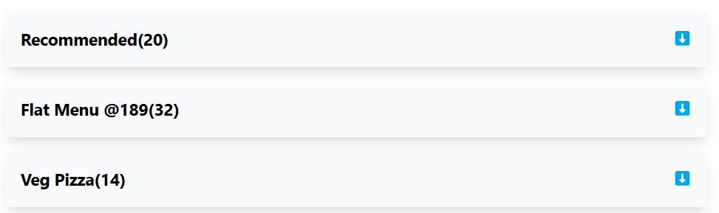

When we click on a specific category or accordion header, the showItems state for that category is toggled to true, causing the accordion content to be displayed.

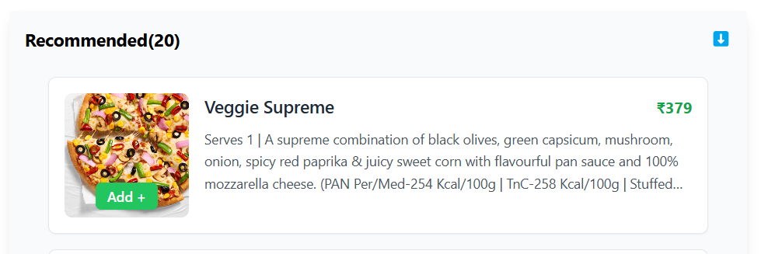

Clicking the header again will hide the content by toggling the showItems state back to false.



>>>

Managing Accordion State in RestaurantMenu

Currently, each RestaurantCategory component (child) manages its own showItems state to control whether its accordion is expanded or collapsed. For example, the Recommended(20) component maintains its own internal state and handles the visibility of its item list.

However, other components - such as Flat Menu @189(32) and Veg Pizza(14) are not aware of the state inside Recommended. In fact, none of the sibling components knows whether another is currently expanded or collapsed.

This happens because each component is managing its own local state independently. As a result, multiple accordions can be expanded at the same time, which may not be the desired behavior.

To ensure that only one accordion is expanded at any given time, we need to lift the showItems state up to the parent component, RestaurantMenu. The parent can then track which category is currently expanded and pass that information down to each child component via props. This way, each RestaurantCategory knows whether it should be expanded or collapsed based on the shared state managed by the parent.

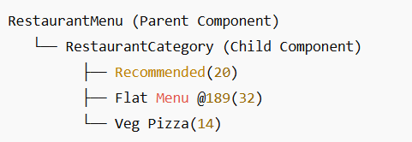

This concept is known as 'Lifting State Up.' We are moving the showItems state from the child components to the parent component.

#### **What is Lifting State Up?**

* **Lifting state up** is a React concept where state is moved from a **child component** to its **parent component**.
* This approach is used when multiple child components need to share or interact with the same state.

### How Lifting State Up Works in React ?

**🎯 Initial State in the Child**

➡️ **In a typical React setup,** each child component manages its own internal state using useState. This makes each component independent, with no shared data between them.  
➡️ **However, when multiple components need to access or modify the same data,** keeping the state in each of them becomes inefficient and leads to redundant code.

**🎯 Move the State to the Parent**

➡️ **Instead of managing state in individual child components,** the state is moved to the parent component.  
➡️ **The parent becomes the "single source of truth,"** managing and controlling the shared state for all components.

**🎯 Pass State and Functions to Children**

➡️ The parent component **passes the state** to the child components via **props**.  
➡️ It also **passes down functions (event handlers)** to the children, enabling them to update the state in the parent when needed.  
➡️ These functions allow child components to modify the shared state **centrally controlled** by the parent.

**🎯 Children Read and Modify the State via the Parent**

➡️ The child components no longer manage the state independently. Instead, they access and modify the state through the parent.  
➡️ When a child component needs to update the state (e.g., when a user interacts with a button), it calls the function passed by the parent to make the change.

**🎯 State Synchronization**

➡️ The **parent synchronizes** the state across all the child components.  
➡️ Any child component that needs to **read or modify** the shared state will interact with the parent, ensuring that all components have **consistent** and **up-to-date** data.  
➡️ When the state changes in the parent, **all relevant child components** are re-rendered to reflect the updated data.

This process allows for centralized state management, reducing inefficiencies and ensuring that shared state is handled consistently across components.

Challenges of Managing State in Multiple React Components and the Benefits of Lifting State Up

Inefficient: Storing the same state in multiple components leads to unnecessary code duplication and increases the complexity of maintaining the state. When you store the same state in multiple components, it leads to code duplication, as each component needs to manage and update its own state. This makes the code harder to maintain, and if updates are required, they may need to be applied to multiple places, increasing the risk of errors and inconsistencies. It also increases the overall complexity of the application.

Inconsistent: When different components manage their own state, it can lead to out-of-sync data between them. Out-of-sync data refers to situations where different parts of the UI (like accordion components) have conflicting states. For example, if each accordion item manages its own expanded/collapsed state, one accordion could be expanded while others remain open, causing an inconsistent UI.

RedundantCode: Keeping state in multiple components results in repetitive logic for handling similar data and state updates across each one. It means that when each component manages its own state (such as the expanded/collapsed state for each accordion item), you end up writing the same logic in each component to handle the state. For example, if each accordion item needs to track whether it's expanded or collapsed, you'll need to implement similar functions and state management in each accordion component. This repetition increases the complexity of the code, makes it harder to maintain, and can introduce bugs if one of the components is updated differently than the others. Instead, it's more efficient and cleaner to "lift" this state to a parent component, where a single source of truth can handle the state for all child components, eliminating the need for redundant code.

SingleSourceofTruth: Having the state managed by a single parent component ensures that all components share the same, consistent data and reduces complexity. **Consistent data** means that all components are using the same accurate and up-to-date information.

### Why Use Lifting State Up? 🚀

**🎯 Sharing State Between Siblings**

➡️ If two or more child components need to **share** or **synchronize** state, you lift the state up to their common parent. This ensures that they can access & modify the same data.

**🎯 Centralized State Management**

➡️ Lifting state up ensures the state is controlled by a **single source of truth**, avoiding issues with **state duplication** or **inconsistency**. This makes the application easier to manage and more predictable.

**🎯 Better Control**

➡️ The **parent component** can control the state and **pass down necessary data** or functionality to its children. This provides centralized control over the flow of data in the app.

### Drawbacks of Lifting State Up 🚀

**🎯 Tight Coupling**

➡️ Lifting state up creates strong dependencies between parent and child components. Changes in the parent may require updates in all child components, making maintenance harder.

**🎯 Overloaded Parent**

➡️When too many components rely on the parent for state, the parent can become overloaded with responsibilities, making it harder to manage & understand.

**🎯 Complex Prop Drilling**

➡️Passing the same state down through multiple layers of components (known as **prop drilling**) can clutter the code and make it harder to follow.

**🎯 Performance Issues**

➡️When the state changes in the parent, all child components that depend on it need to re-render. This can lead to performance bottlenecks, especially in large apps.

**🎯 Less Flexibility**

➡️Child components lose some flexibility since they now depend on the parent for their state. If you need to reuse a child component in another part of the app, it becomes more difficult to adapt without changing the parent.

**🎯 Difficult to Track State**

➡️As the app grows, tracking state changes in one central place (the parent) can become complex, making debugging and updates more challenging.

Centralizing Accordion State Management with Lifting State Up

In this example, we want to ensure that **only one category accordion** is expanded at a time. To achieve this, we will **lift the** showItems **state** from each individual RestaurantCategory child component to the RestaurantMenu parent component.

#### **Why Lift State Up?**

* **Single Source of Truth**: Lifting the state to the parent makes it the "single source of truth" for the accordion's expanded/collapsed state. This ensures consistency across components, as the state is centrally managed.
* **Improved Control**: The parent component (RestaurantMenu) controls the accordion's behavior by managing the state and passing it down to the child components via props.

#### **How It Works?**

* **Responsibility Shift**: The responsibility for determining which accordion is expanded moves from the individual RestaurantCategory components to the RestaurantMenu parent.
* **Centralized State Management**: The RestaurantMenu parent component now controls the expanded/collapsed state of all accordion categories, ensuring that only one category is expanded at any time.
* **Passing Props**: The parent component passes down both the state and functions as props to each child (RestaurantCategory), allowing them to read and modify the state when necessary.

#### **Key Benefits of Lifting State Up?**

* **State Control**: The parent (RestaurantMenu) manages the expanded/collapsed state and passes the necessary data to each child.
* **Accordion Behavior Control**: The parent ensures that only one category is expanded at a time, and automatically collapses other categories when a new one is expanded.

#### **Visualizing States and Components**

Before diving into the implementation, let’s use **React DevTools** to visualize the component structure and understand the flow of state through the components. This will help us confirm how the state is managed and ensure smooth interaction between parent and child components.

## 🔧 What is React DevTools?

React DevTools is a **browser extension** for **inspecting, debugging, and optimizing** React applications.  
It helps developers **visualize the component tree**, check props/state/hooks, and improve performance.  
Available for **Chrome**, **Firefox**, and **Edge**.

💬 Why Do We Use React DevTools?

1. **Debugging** – Inspect and understand the structure of React components.
2. **Performance Tuning** – Detect slow components and unnecessary re-renders.
3. **Real-Time Testing** – Edit state/props on the fly to test behavior without changing code.

👉 This tool makes it **easier to troubleshoot, test, and fine-tune** your app during development.

#### 🔑 Core Features of React DevTools

#### **1. Component Tree**

* Shows the **full structure** of React components.
* Allows viewing of **props** , **state** & **context**
* Highlights **parent-child** relationships between components.

✅ Helps trace how data flows and where bugs might be coming from.

***2. Profiler***

* Records **render times** of components.
* Visualizes:
  + Which components **re-rendered**
  + **How long** each render took

✅ Useful for finding performance bottlenecks.

***3. Edit Props and State***

* Directly modify component **props and state** in the DevTools.
* Changes reflect **instantly** on the UI.

✅ Great for testing different states without touching code.

***4. Hooks Inspection***

* Shows values of **React hooks** like useState, useEffect, etc.
* Also supports viewing **custom hooks**.

✅ Helps in debugging functional components and logic inside hooks.

***5. Component Search***

* Quickly **search components by name**.
* Makes navigating large apps easier.

✅ Saves time when working on big projects.

Let’s go back to our Accordion example and view its component hierarchy in React DevTools.

**In the figure below:**

The **left-hand side (LHS)** represents the **UI Layer**, which visualizes the **Virtual DOM (VDOM)**.

The **right-hand side (RHS)** represents the **Data Layer**, which contains the component’s **state and props**.

Each RestaurantCategory component maintains its own showItems state. For example the first RestaurantCategory accordion is collapsed, which means its showItems state is set to false.

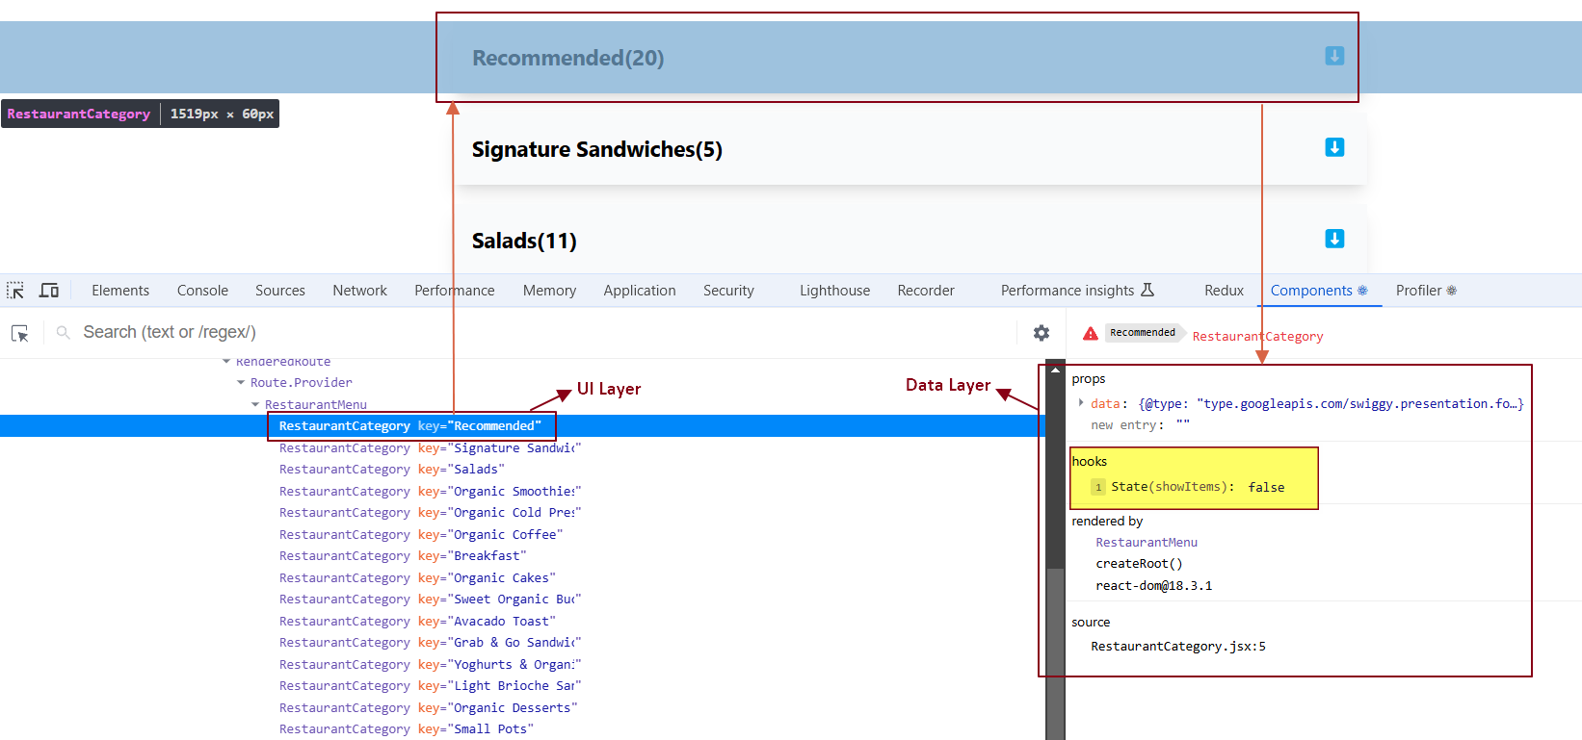

When we expand this accordion, the showItems state for that specific component changes from false to true.

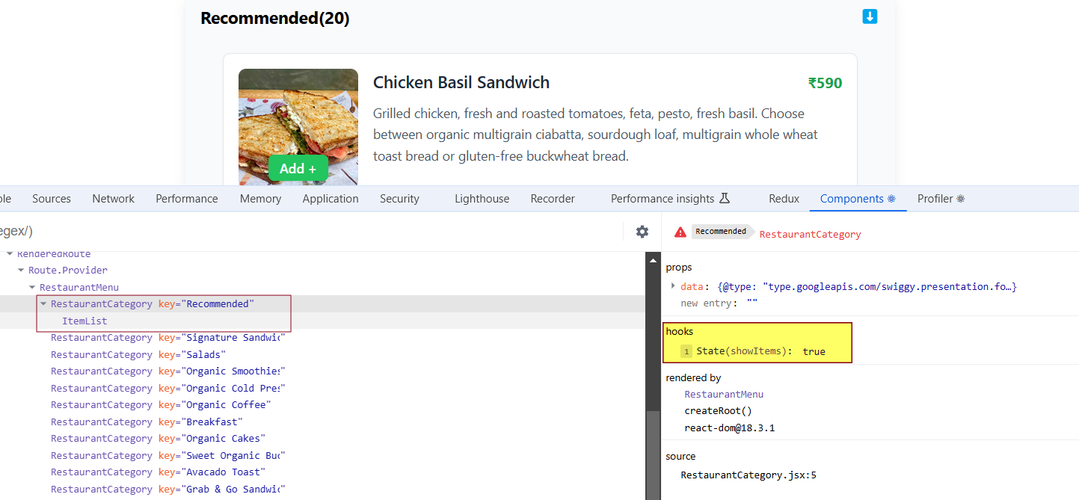

Now, if we look at the second RestaurantCategory accordion component, its showItems state is still set to false, as it has not been expanded yet.

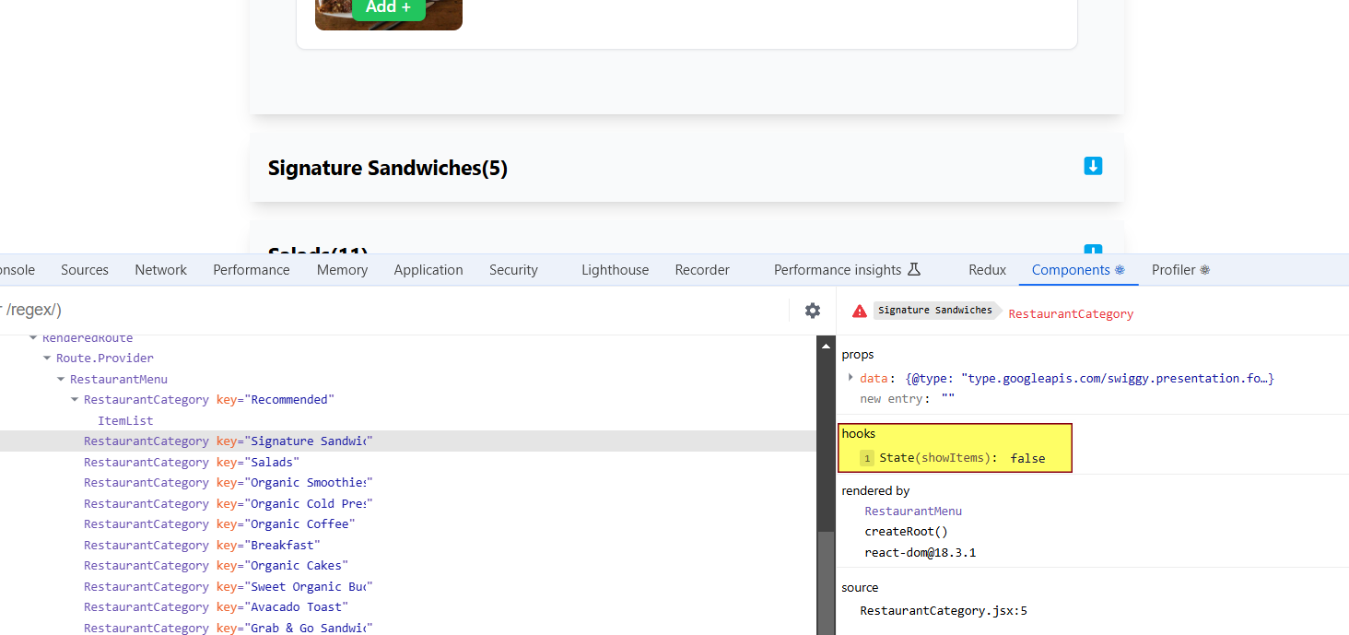

In the component hierarchy below, the ItemList component receives **props** from the RestaurantCategory component, as shown in the **Data Layer** on the right-hand side.

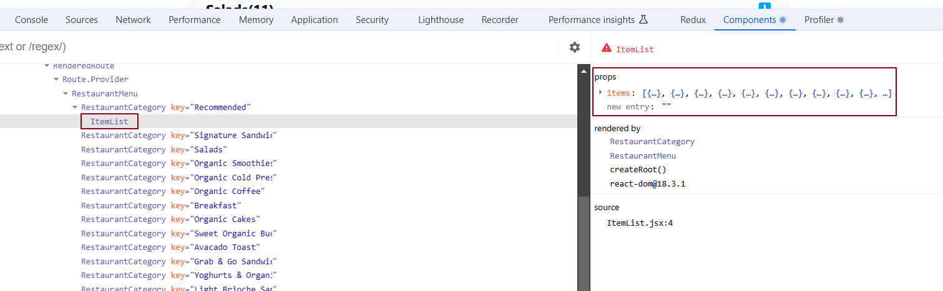

### What is the Profiler in React DevTools?

When building large-scale applications with many components, **debugging performance** can be challenging. The **Profiler** in React DevTools helps by recording the entire **user journey**, showing how the page was rendered and how long it took to render each component.

#### Key Features of the Profiler -

**1. Records User Actions:**

* Tracks every action a user performs on the UI.
* Displays the rendering timeline of components through a **Flame Graph**.

**2. ON/OFF Switch:** Profiler provides a **toggle switch** to turn the recording on or off.

**3. Flame Graph:**

* Shows the **render times** for components.
* Helps identify which components took the most time to render.
* Displays the time taken by **layout** and **passive effects** during rendering.

#### How to Use:

1. **Start Recording:** Click the **record** button in the Profiler to begin capturing.
2. **Interact with UI:** Perform operations on the UI.
3. **Stop Recording:** Manually stop the recording to view the **Flame Graph**.

The **Flame Graph** helps you analyse component performance and find **bottlenecks** that can be optimized.

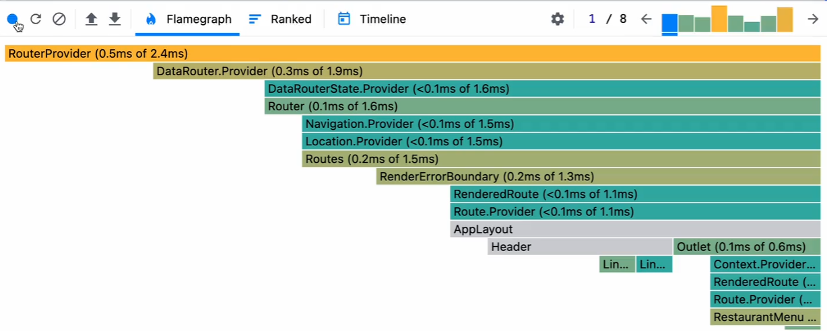

### **Layout and Passive Effects in React**

In React, **layout** and **passive effects** refer to two different types of side effects that happen during the rendering process, especially when using useEffect and useLayoutEffect. Understanding the difference between these two can help in optimizing React applications.

Implementing "Lifting State Up" for Centralized Accordion State Management

When implementing an accordion, if one RestaurantCategory accordion is expanded, it’s important for all other RestaurantCategory components to be aware of this state change. To achieve this, we’ll use the "lifting the state up" concept. Currently, each RestaurantCategory component manages its own showItems state to determine whether it should expand or collapse. However, this decentralized control can lead to issues when trying to synchronize state across multiple components.

Instead, we will move the showItems state to the parent component, RestaurantMenu. This way, the parent component will dictate whether each RestaurantCategory should show its items or not. By lifting the showItems state to RestaurantMenu, we centralize the state management, making it easier to control the behavior of all child components consistently.

The RestaurantCategory components will no longer maintain their own showItems state; instead, they will rely on the RestaurantMenu to determine their visibility. This approach ensures seamless coordination between the components. Let’s implement the "lifting the state up" approach in our accordion feature.

### RestaurantCategory is now a controlled component because its behavior is controlled by the parent component, RestaurantMenu. Previously, when RestaurantCategory had its own showItems state, it was an uncontrolled component, as RestaurantMenu did not manage its state or behavior. In that case, the child component (RestaurantCategory) independently handled its own state and decided whether to show or hide the accordion.

### What Are Controlled and Uncontrolled Components?

#### **1**. **Controlled Component**

A component is called controlled when its state and behavior are managed by its **parent component via props.**

**📌 Example:** RestaurantCategory becomes a controlled component when RestaurantMenu manages its visibility by passing the showItems state as a prop.

#### **2.** **Uncontrolled Component**

A component is uncontrolled when it **manages its own state internally**, without relying on the parent.

**📌 Example:** When RestaurantCategory maintained its own showItems state locally, it was uncontrolled, because it independently handled its visibility.

### Main Difference Between Controlled and Uncontrolled Components

**Controlled Component:** Relies on its **parent component** for both **state** and **behavior** (via props).  
Example: RestaurantCategory becomes controlled when RestaurantMenu manages its showItems visibility through props.

**Uncontrolled Component:** Manages its **own internal state** and behavior without parent interference.  
Example: RestaurantCategory was uncontrolled when it internally managed the showItems state.

**Passing Props from Parent to Child: Positive and Negative Cases**

Let’s control the child components by passing the showItems prop from the parent component.

Parent RestaurantMenu Component -

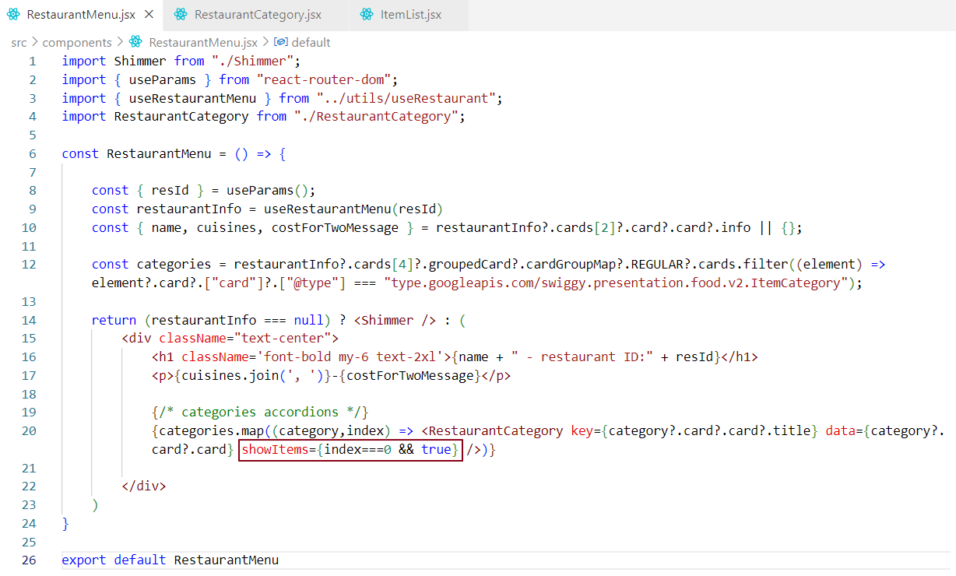

Child RestaurantCategory component -

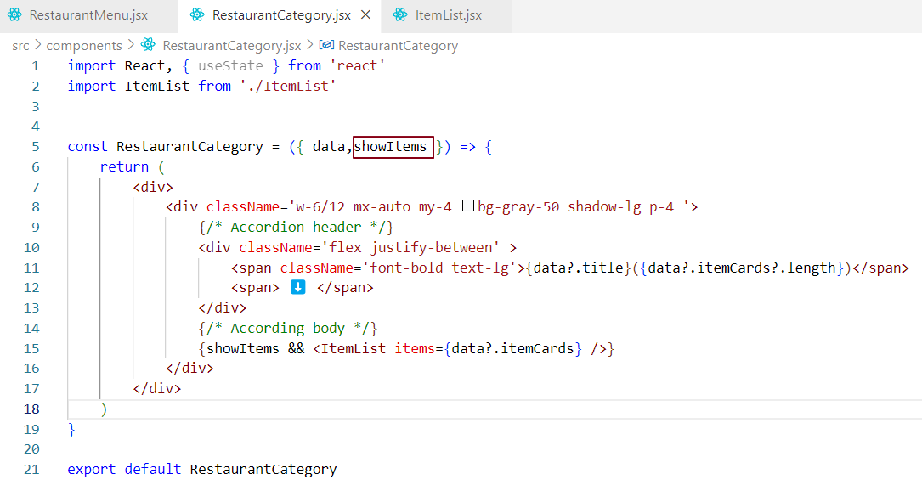

The parent component is responsible for controlling its child components. At the moment, it controls the expansion of these components. Specifically, the parent controls the expansion of the first child component.

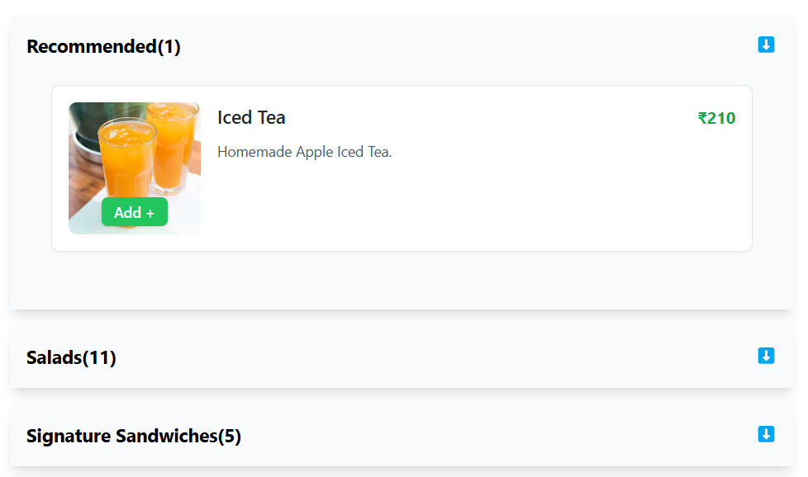

### Code Explanation -

### Positive Case (When index === 0):

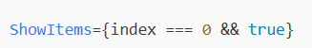

In this case, when index === 0, the expression evaluates to true because:

* index === 0 is true (as the condition is satisfied).
* true && true results in true, so the value passed as the ShowItems prop will be true.

So, if index === 0, the parent will pass true to the child component (RestaurantCategory).

This is the **positive case**, where the value being passed is explicitly true.

### Negative Case (When index !== 0):



If index !== 0, the expression index === 0 becomes false. Since the expression is using the logical && operator:

* index === 0 is false (as the condition is not satisfied).
* false && true results in false.

So, if index !== 0, the value passed as the ShowItems prop will be false. This is the **negative case**, where the value passed to the child component is false.

➡️ **Currently, we’ve hardcoded the logic to allow only one accordion to be expanded at a time.**  
  ➔ When one accordion is expanded, the others remain collapsed.

➡️ **To make this behavior dynamic, we’ll use a state variable called** showIndex **to track the index of the expanded accordion.**  
  ➔ If showIndex is 0, only the first accordion will be open.  
  ➔ If showIndex is 1, the second one will be open.  
  ➔ All others will remain collapsed—ensuring that only one accordion is expanded at any given time.

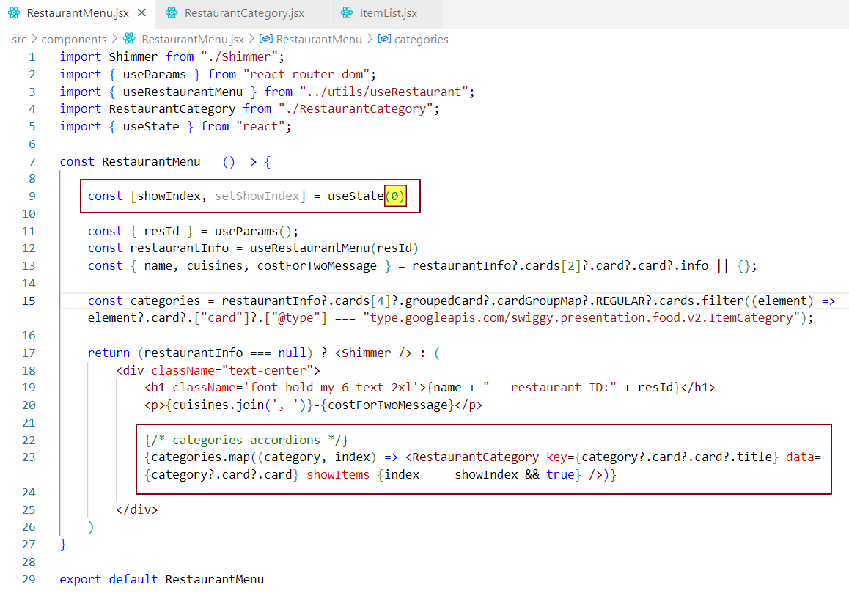

➡️ In the current setup, the showIndex state in the parent component (RestaurantMenu) determines which child accordion is expanded.

➡️ When a child accordion is clicked, we want to update the showIndex state to expand that specific accordion while collapsing the others.

➡️ The challenge is that showIndex is not stored within the child components—it is passed down from the parent as a prop.

➡️ Since child components cannot directly modify the parent’s state, we need a way to notify the parent when a child accordion is clicked.

➡️ This allows the parent to update showIndex accordingly, ensuring that the correct accordion is expanded while keeping the state centralized and in sync.

Let’s move on to the coding part.

RestaurantMenu.jsx- (Parent Component)

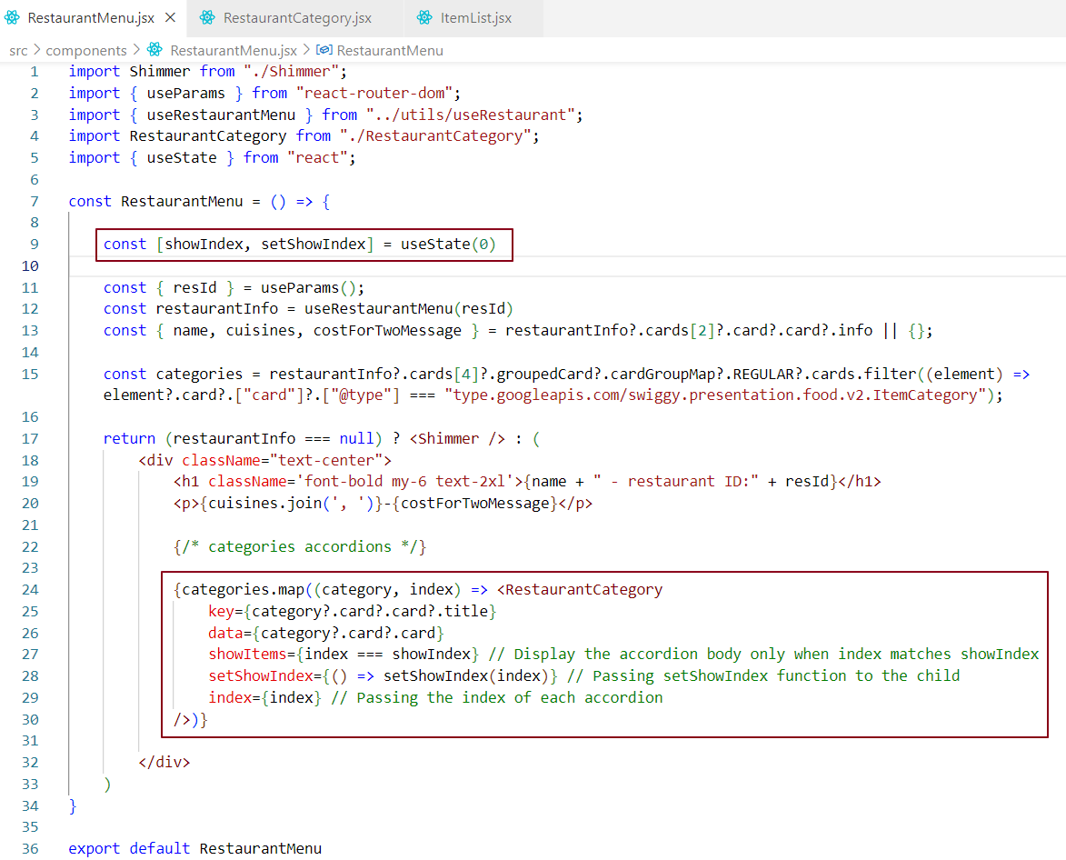

RestaurantCategory.jsx – (Child Component)

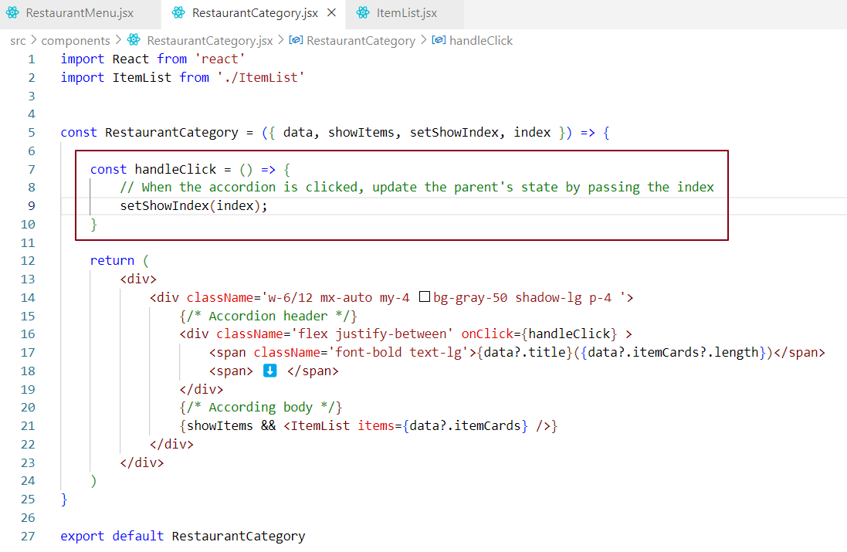

Lifting State Up: Code Flow and Explanation

#### **1. State in the Parent Component (RestaurantMenu)**

The RestaurantMenu component defines the showIndex state. This state is used to determine which accordion should be shown as expanded.



#### **2. Passing State to Child Component**

The parent (RestaurantMenu) passes the showIndex state and the function setShowIndex down to the child (RestaurantCategory) as props.

* showIndex determines which accordion should be shown.
* 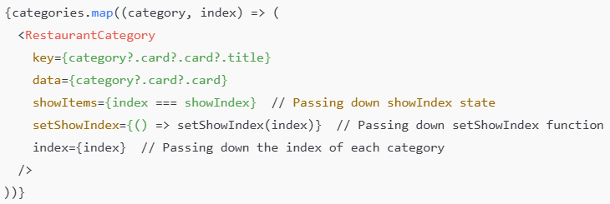setShowIndex is the function the child will use to update the parent's state when an accordion header is clicked.

#### **3. Triggering State Update in the Child (RestaurantCategory)**

In the RestaurantCategory component, when a user clicks the accordion header, the handleClick function is triggered.

* The handleClick function calls the setShowIndex function (which was passed from the parent) and updates the showIndex state in the parent.

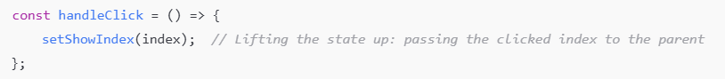

#### **4. Updating the Parent’s State**

When setShowIndex(index) is called, the showIndex state in the parent component (RestaurantMenu) is updated to the index of the clicked accordion.

* React re-renders the parent component because the state has changed.

#### **5. Conditionally Rendering Based on Updated State**

When a user clicks an accordion header, the setShowIndex(index) function updates the showIndex state in the parent component (RestaurantMenu). This causes the parent component to re-render.

During this re-render:

* All RestaurantCategory child components receive the updated showIndex as a prop.
* Each child compares its index with showIndex to decide whether to show or hide its accordion body.

Although only one accordion is visually expanded, **react re-renders all the** RestaurantCategory **components** because their showItems prop changes based on the updated showIndex.  
This is a common React behavior—**whenever a prop changes, the component re-renders.**

⚠️ As a result, this approach can impact performance when rendering a large number of accordions, since every toggle causes all of them to re-render.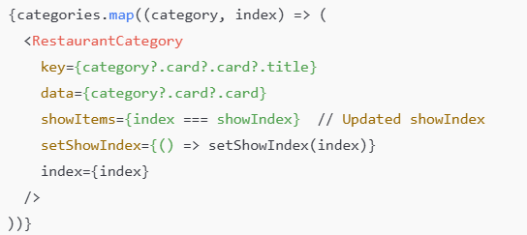

## Alternate Ways to Pass the State Setter (setShowIndex)

When lifting state up in React, the parent component often needs to pass down a state updater function (like setShowIndex) to child components. Here are **three common and clean ways** to do this:

***Option 1: Inline Arrow Function (Current Implementation)***

This method binds the index value directly in the JSX using an arrow function:

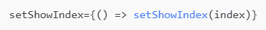

✅ **Pros:** Simple and readable , Useful for quick one-liners.

❌ **Con:** A new function is created on every re-render of the parent component. Since this function is passed as a prop to child components, it causes React to treat it as a prop change—even if the logic hasn't changed resulting in unnecessary re-renders of all child components.

***Option 2: Define Handler Function Inside the map() Loop***

This approach still creates a new function reference each time the component re-renders. The function itself is constant (doesn’t change), but React **still sees a new reference** on each render, which leads to unnecessary re-renders.

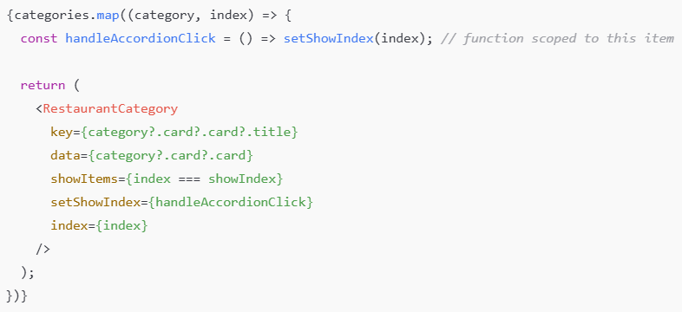

***Option 3: Pass the Setter and Index Separately***

In this approach, the parent just passes setShowIndex and index as props. The child takes responsibility for calling the function.

With this approach React doesn't need to recreate a new function on every render. The child simply invokes setShowIndex(index) when the accordion is clicked. The index is passed separately so the child component knows which accordion to expand. The setShowIndex function doesn’t change unless the parent’s state changes.

**Parent (**RestaurantMenu.jsx**)**

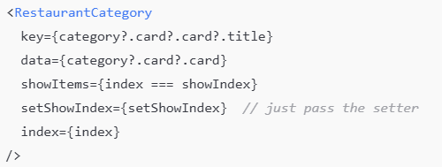

**Child (**RestaurantCategory.jsx**)**

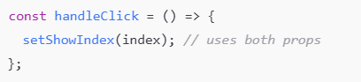

***Recommendation***

For better performance and flexibility, choose Option 3.

**Why This Works (Accordion Behavior in React)?**

* When a user clicks on a restaurant category, the child component invokes a handleClick function, which calls a callback to update the showIndex state in the parent.
* This state update triggers a re-render of the parent component.
* The parent then passes the updated showItems prop to each child.
* As a result, only the selected accordion is expanded while all others are collapsed, based on the current showIndex.

When the user clicks on the first accordion header, it expands the first accordion while collapsing the others.

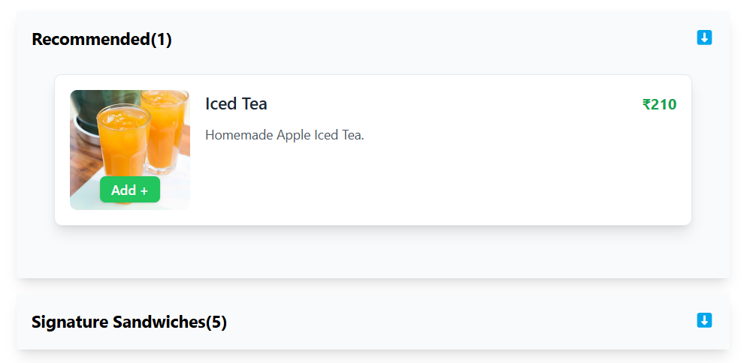

When the user clicks on the second accordion header, it expands the second accordion while collapsing the others.

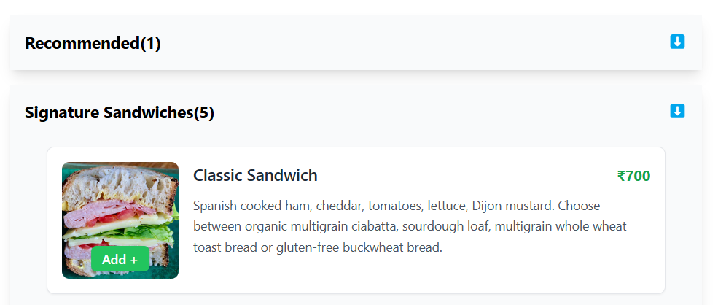

***Note - On initial load, Accordion 1 (Recommended(1)) is expanded by default, while the remaining accordions are collapsed.***

In the UI example below, **Signature Sandwiches (5)** is the first accordion item, **Salads (11)** is the second, and **Organic Smoothies** is the third. Let's use React DevTools to visualize the state of the **Restaurant Menu** parent component when different accordion items are clicked.

**Clicking the first accordion updates the parent component's state to 0, indicating the active accordion index.**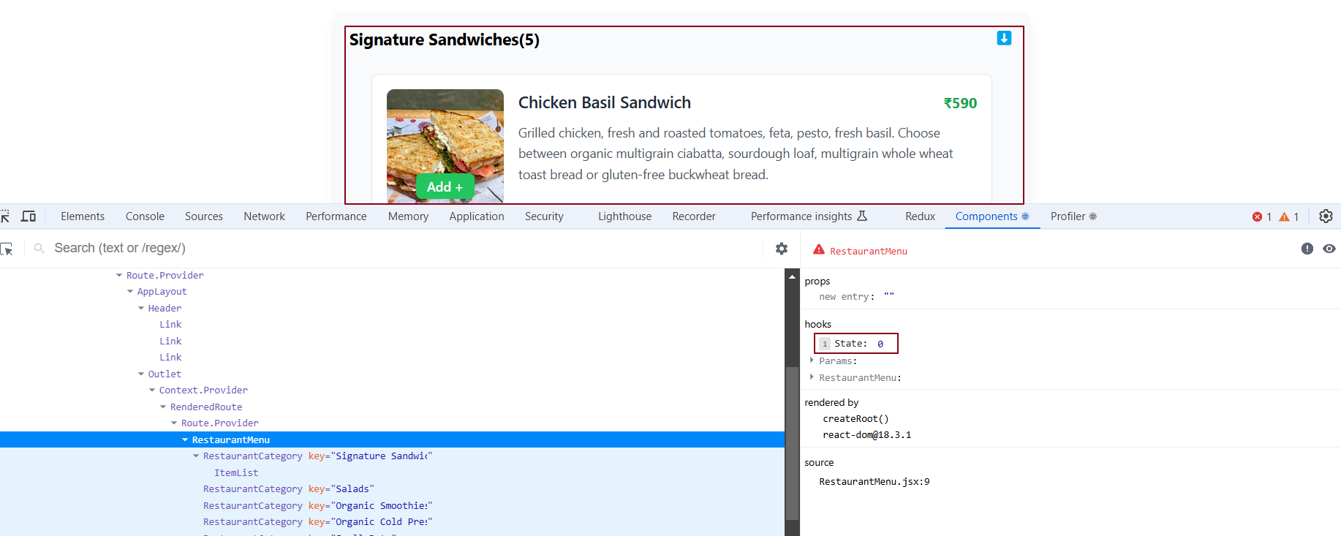

**Clicking the second accordion updates the parent component's state to 1, indicating the active accordion index.**

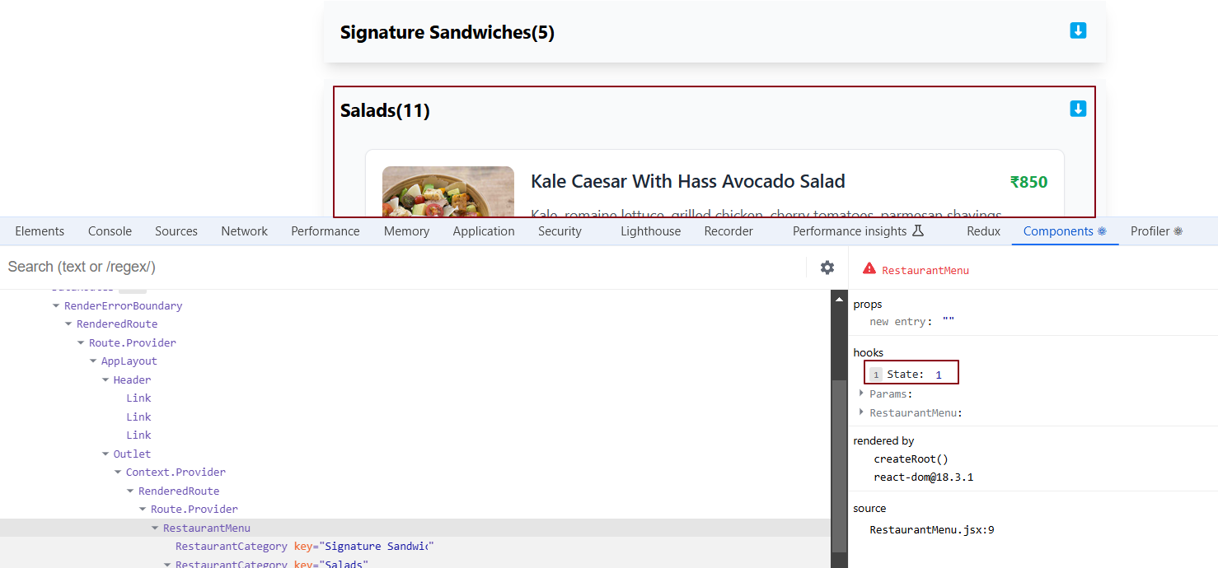

**Clicking the third accordion updates the parent component's state to 2, indicating the active accordion index.**

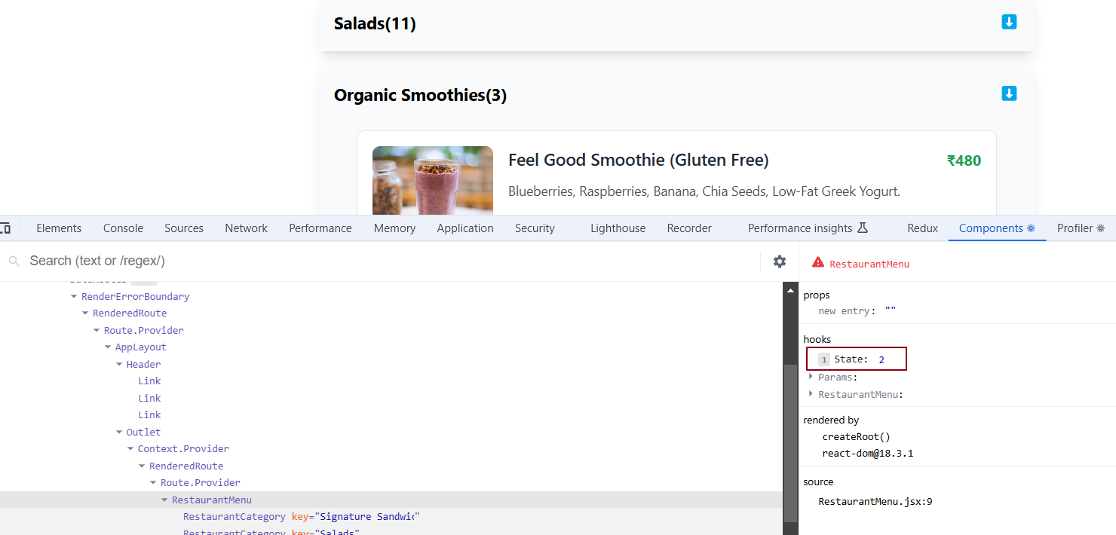

Each **RestaurantCategory** component (accordion) receives setShowIndex and showItems as props directly from the parent component, **RestaurantMenu**. These props are individually passed to each accordion by the parent. When an accordion header is clicked in the child component, it triggers a state change in the parent, which can be clearly observed in the data layer. The highlighted state in the data layer represents the showIndex state in the parent component (**RestaurantMenu**), which is controlled through the child component’s accordion header click.

Now, let’s dive into the concept of **props drilling.**

What is Props Drilling in React?

**Prop Drilling** in React refers to the process of passing data (props) from a parent component to its child, then to the child's child, and so on, until the data reaches the component that needs it. This chain of passing props continues through intermediate components, even if those components don’t require the data themselves.

**Example -**

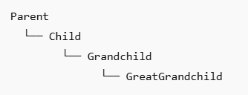

Now, if the Parent needs to pass some data to GreatGrandchild, it will go through each intermediate component.

**Parent** → **Child** → **Grandchild** → **GreatGrandchild (target component)**

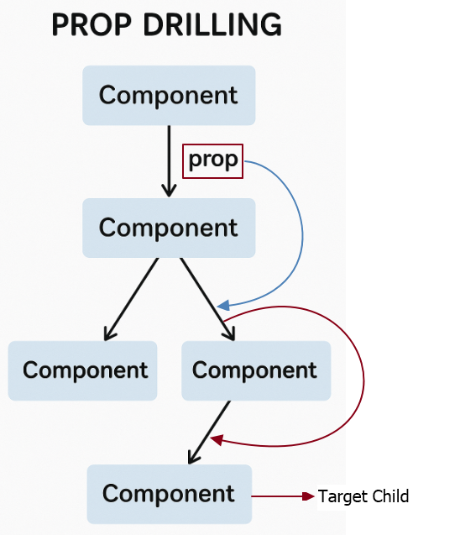

### ✅ When It's Okay to Use Prop Drilling

**✔️ It's fine if the hierarchy is small (like 2–3 levels deep)**

That means if your **Parent** → **Child** → **Grandchild** structure is only **2 or 3 layers deep**, it's generally not a problem to pass props manually through each level. Here's why:

* **Minimal code overhead**: You're only passing the data through one or two intermediate components.
* **Easy to manage**: It’s clear and straightforward to trace where the data is coming from and where it’s going.
* **No extra abstraction needed**: You don’t need to introduce tools like Context API or Redux just to manage a small amount of data flow.

### ❌ Problems with Prop Drilling (When the Hierarchy is Long)

1. ***Intermediate components become messengers***

* Props have to be passed through components that **don't even use them**.
* 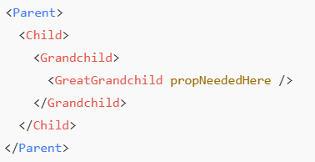This makes your code **messy, harder to read, and harder to maintain**.

Here, Child and Grandchild don’t care about the prop but are forced to forward it.

1. ***Unnecessary re-renders***

* When a prop changes, **all components in the chain** re-render - even those that don’t use the prop.
* This can lead to **performance issues**, especially in large apps.

React's rendering logic: Any component that receives new props will re-render by default, **even if it doesn't use them directly**, unless optimized with React.memo or similar techniques.

### ✅ React Best Practice:

### **Do not pass props to a component if it doesn’t need them.**

In the following component hierarchy -

**RestaurantMenu → RestaurantCategory → ItemList**

Data is passed from RestaurantMenu all the way down to ItemList through multiple layers, even if intermediate components don't use the data themselves.

RestaurantMenu.jsx (Parent) -

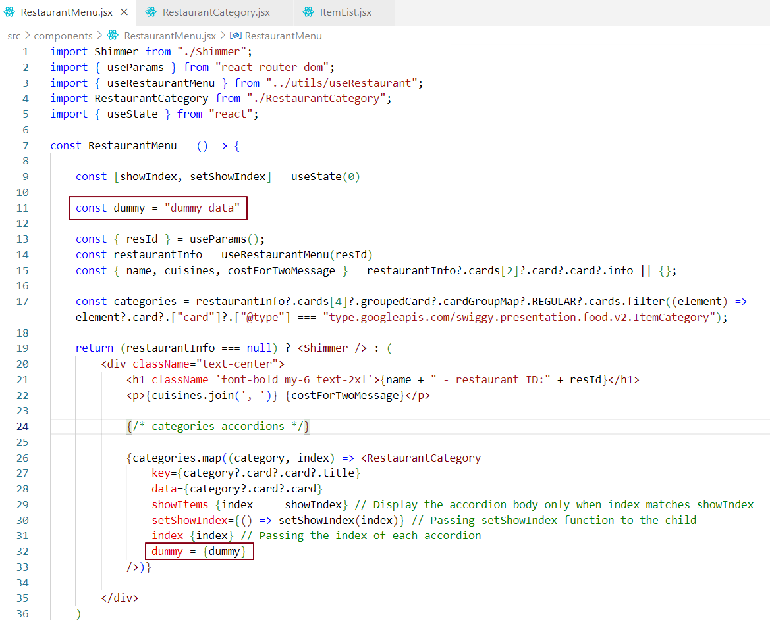

RestaurantCategory.jsx (Intermediate child) -

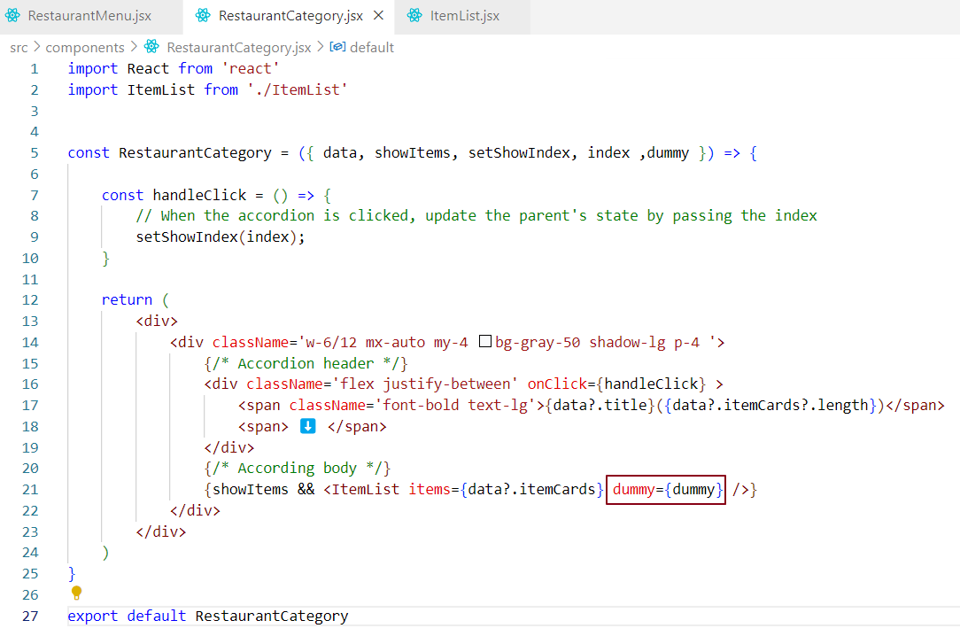

ItemList.jsx (Target Child) -

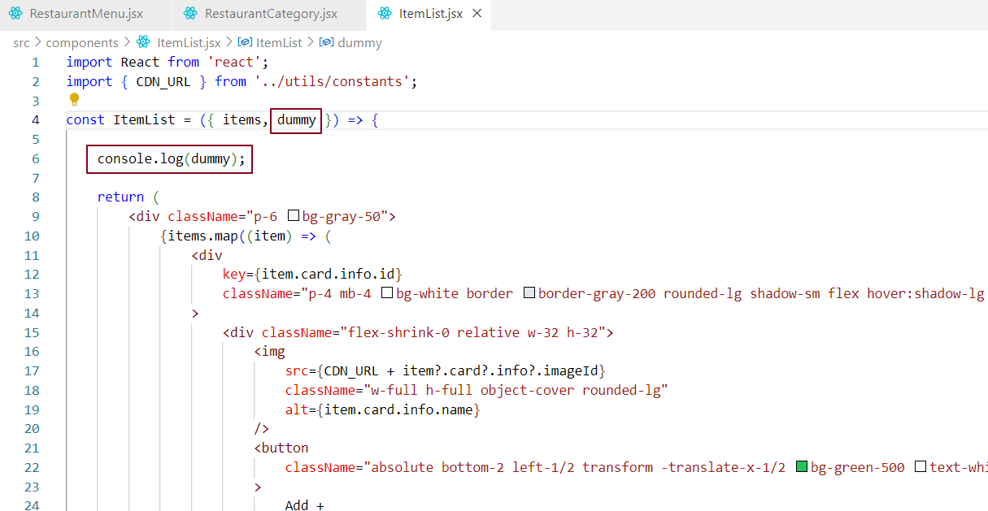

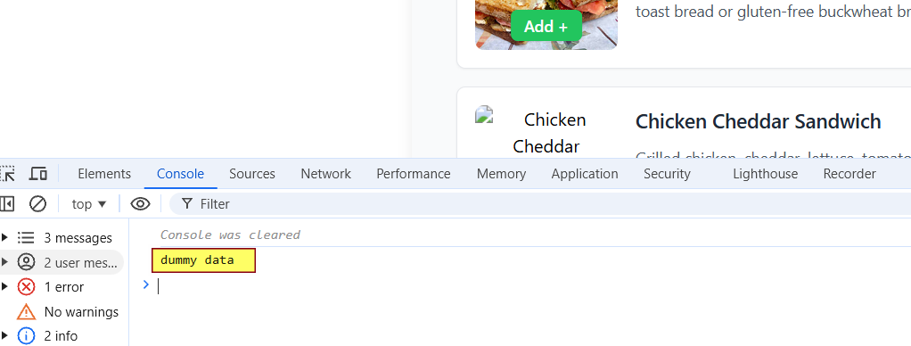

To overcome the issues caused by prop drilling, we can use state management solutions like Redux or the Context API.

### Solution for Deep Chains

For long hierarchies, use tools like **Redux** or the **React Context API** to manage and share data without passing props through multiple levels.

In large applications, we often need to maintain **global data** that can be accessed from anywhere in the app, regardless of the component's nesting level. To achieve this, react provides a powerful feature called the **Context API**. By using React Context, we can **avoid prop drilling** and make data more accessible and manageable.

What is React Context?

**React Context** is a built-in mechanism in React that enables **global data sharing** across the component tree **without prop drilling.** It allows deeply nested components to access shared state directly, bypassing the need to pass props through every intermediate component.

### Advantages of React Context

***1.Centralized Data Access***

Enables a single source of truth for shared data, allowing components to consume it directly without manually passing props through each level of the component hierarchy.

***2.Eliminates Prop Drilling***

Simplifies the component tree by avoiding the need to forward props through intermediate components that don’t use them, leading to cleaner and more maintainable code.

***3. Lightweight Global State Management***

Ideal for managing cross-cutting concerns like authentication status, UI themes, or localization—especially when multiple components across different branches need access to the same data.

**Note -** React Context is a more efficient and reliable way to manage global state than local storage, which is slower and less dependable.

How can we create and use Context in a functional component?

To create and use Context in a functional component, follow these steps:

✔️ **Create a Context:** Use React.createContext() to create a context. This will provide two things: A Provider and a Consumer. The Provider is used to pass data down to components, and the Consumer is used to access that data.

✔️ **Wrap the component tree with the Context Provider:** Use the Context Provider to wrap your component tree and supply the value you want to share.

✔️ **Consume the Context in child components:** Use the useContext hook to consume the context value in any child component.

### *Step 1: Create Context*

### 

### In this context, we are importing the createContext API from the React package and using it to create a context. We are not just creating a context, but also initializing it by passing an object as the default value to this createContext API. This approach is commonly used to manage and share state across components.

***Step 2.1: Use the useContext Hook to Access the Context Inside a Component (Header.jsx)***

### 

***Step 2.2: Use the useContext Hook to Access the Context Inside a Component (RestaurantCard.jsx)***

### 

### You can see the context data being used in the **Header** and **RestaurantCard** components, as highlighted below.

## 

## 🔄 How Can We Update Context in a Functional Component?

### *✅ Overriding the Default Value of Context*

In React, the createContext API allows you to define a default value. However, in real-world applications (e.g., after user login), you often need to **override** that default value dynamically.

*📘* ***Scenario***

* A context is created with a default value, such as:



* Multiple components consume this context to access loggedInUser.
* You want to override the default context value **after an API call** (e.g., fetching authenticated user data).

***🛠️******Solution***

To dynamically update the context:

1. **Use** useState **in your top-level/root component** to manage the context value.
2. **Run your logic (e.g., API call)** using useEffect to fetch user data after login or app load.
3. **Update the context value** by updating the state.
4. **Wrap your components with** <Context.Provider> and pass the updated state as the value.

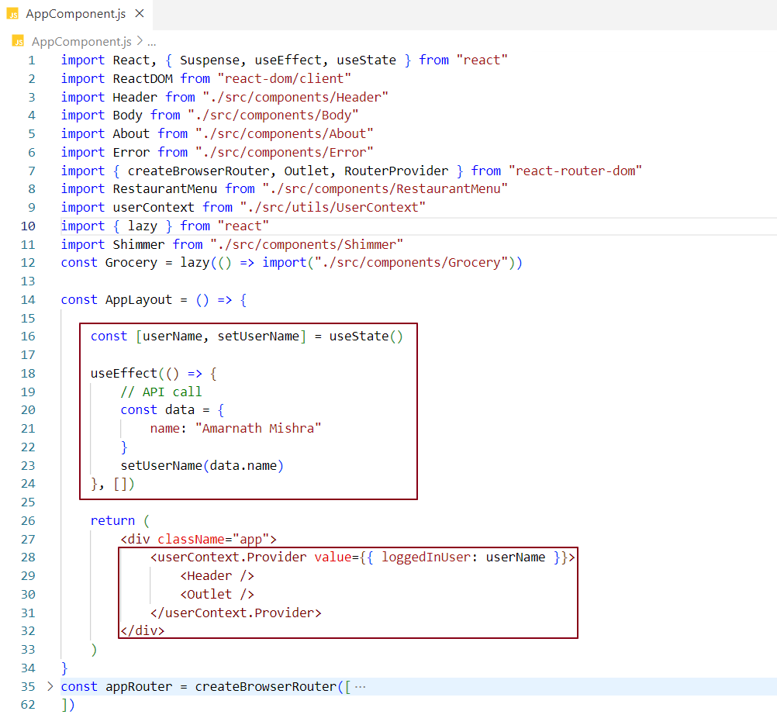

To dynamically update the context in the AppComponent component (which acts as the root component in this case), we follow these steps

✔️ We initialize a state variable userName using useState.

✔️ Inside a useEffect, we simulate an API call and update the userName state with the fetched user data.

✔️ We pass this updated userName to the context by wrapping the JSX with <userContext.Provider> and supplying a value prop like

  
  
Any component wrapped within userContext.Provider (such as <Header /> and <Outlet />) can now access the dynamic context value using the useContext hook.

This approach ensures that context data is notstatic and can be updatedbasedonruntimelogic, such as an authentication response. Providing the context at the root level allows allnestedcomponents to consume the updated user data consistently.

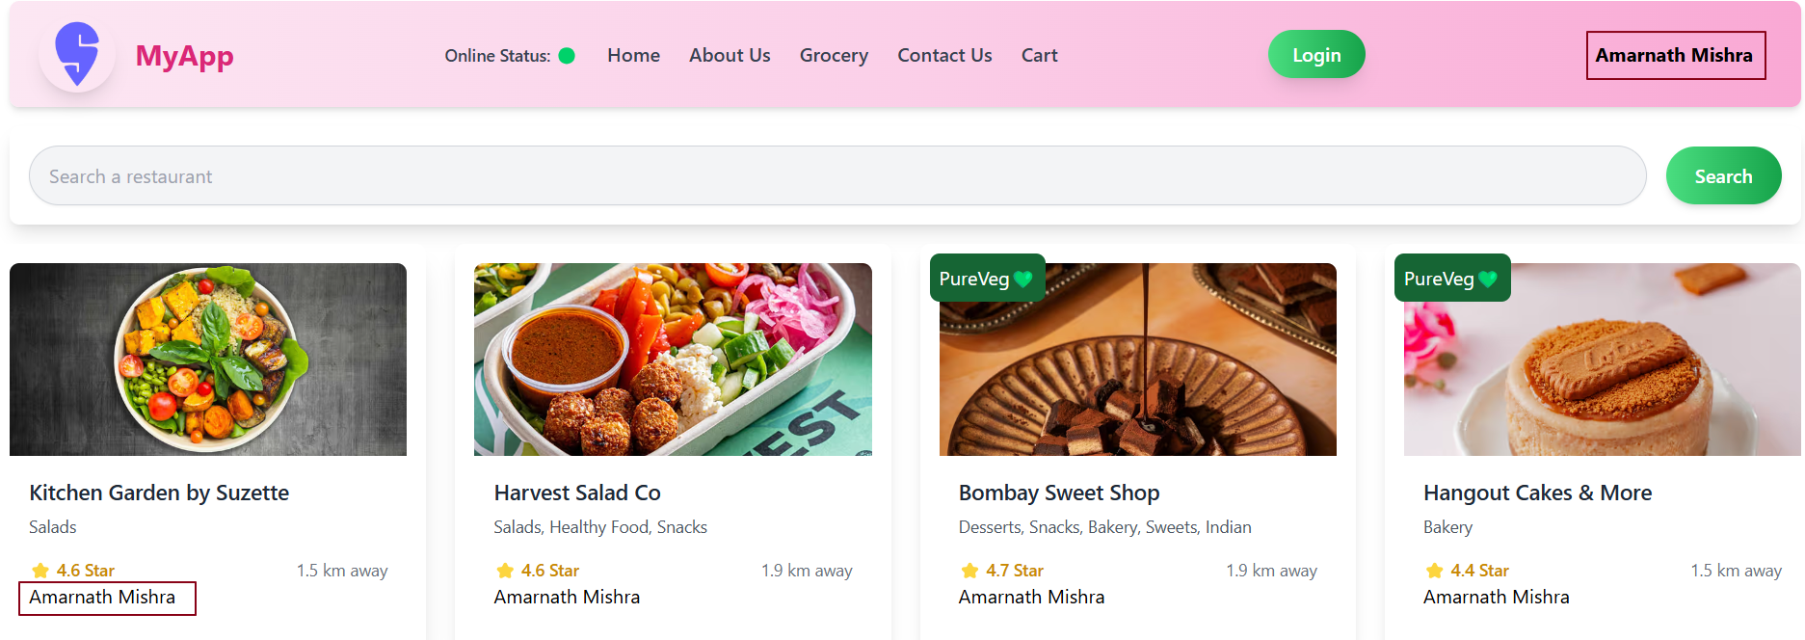

### Providing Context to Specific Components

In the current example, context is provided to the entire application by wrapping the root component (AppLayout) with <userContext.Provider>.

However, it's also possible to scope the context to **specific components only** by wrapping just those components with the <Context.Provider>.

**Components** not **wrapped** by the Provider will fall back to the **default context value** defined during context creation.

**Components**wrapped by the Provider will receive the **custom context value** passed via the value prop.

This approach offers **flexibility** - you can restrict context access to only the parts of the app that need it, avoiding unnecessary re-renders and improving performance.

Why limit Context to Specific Components ?

We use context in specific parts of the app instead of the whole app when

👉 **Only some components need the shared data.** Instead of wrapping the entire app with context, we wrap only the components that actually use it. This makes the code cleaner and avoids connecting unrelated components to the context.

👉Reducing unnecessary re-renders**.** When context data changes, all components that use it will re-render. If we limit the context to just the components that need it, we prevent other parts of the app from re-rendering unnecessarily which improves performance.

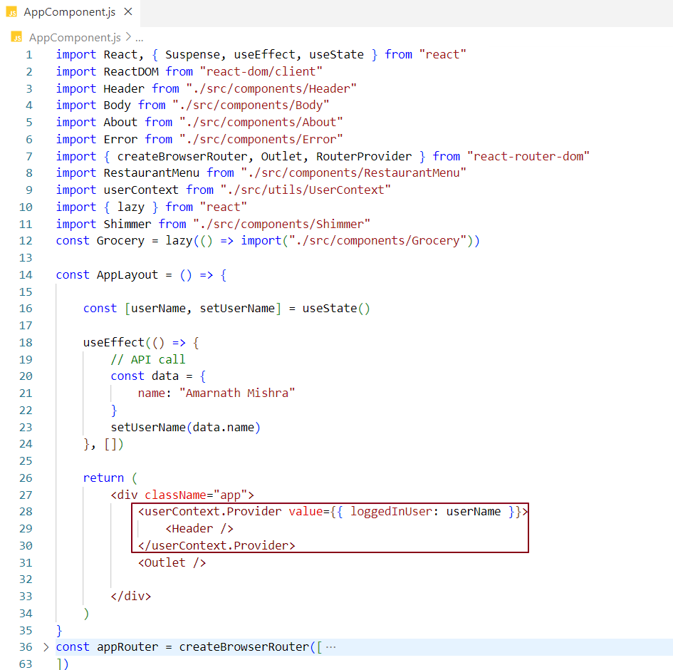

### Explanation of Code Base: Providing Context to Specific Components

* **Context Creation:** A userContext is created using createContext() with a default value of "Default User". This serves as the fallback value if no custom context is provided to a component.
* **AppLayout Component:**
  + **State Management:** Inside the AppLayout component, useState is used to store the user's name (userName), which will be dynamically set based on an API call.
  + **API Simulation:** The useEffect hook simulates an API call to fetch the user’s name. Once the name is fetched, it is set in the userName state.
  + **Context Provider:** The context (userContext.Provider) is used to pass the value of userName as the loggedInUser property to the Header component.
  + Only components wrapped by userContext.Provider will have access to this updated userName value.
* **Header Component:** The Header component is wrapped with userContext.Provider, meaning it receives the context data (loggedInUser with the dynamic value of userName).
* **Outlet Component:** The **Outlet** component is not wrapped by userContext.Provider. As a result, it only has access to the default context value ("Default User"), not the updated userName.
* **Routing with React Router:** React Router is used to manage the routes of the app. The AppLayout component serves as the root layout, where the context is provided to certain components (like Header). The Outlet component is used to render child routes (like Body, About, RestaurantMenu, and Grocery).

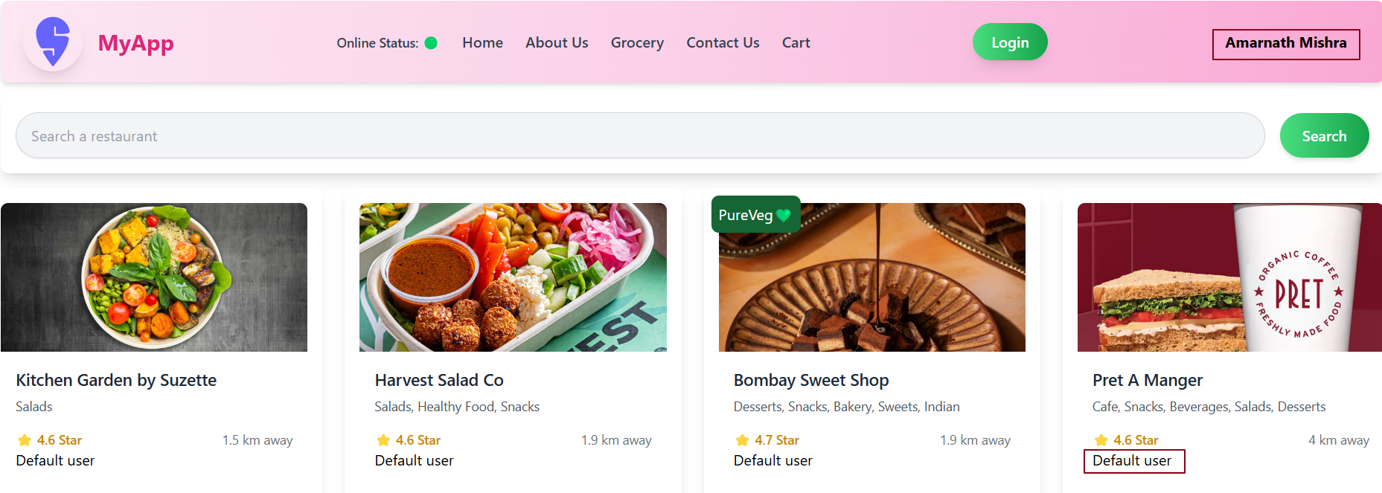

In our app, the **Header** component receives the overridden context data, while the **Body** component receives the default context value.

Nested Context Providers in React

Yes, you can use nested context providers in React. This means you can have multiple <Provider> components, with one inside the other, each providing a different value to different parts of your app.

**Example 1 :**

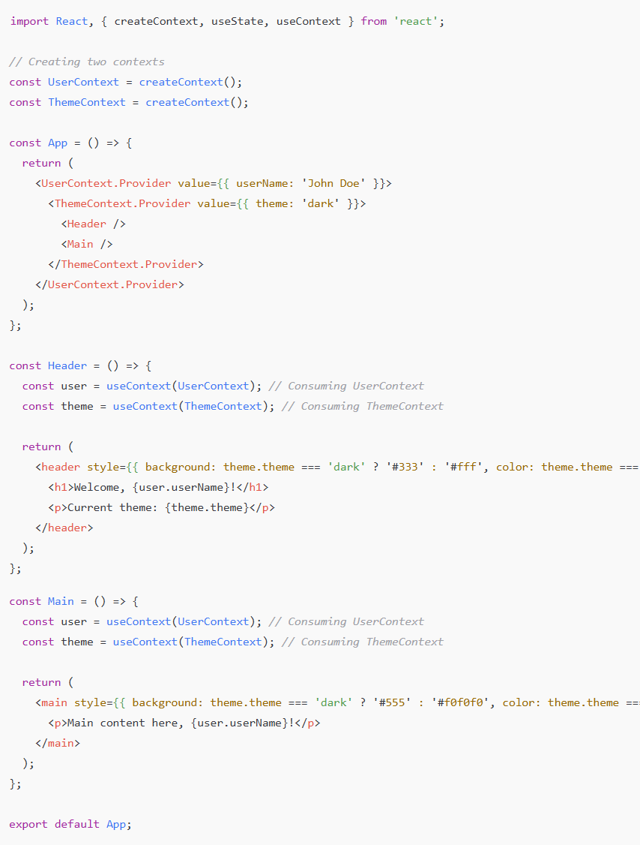

### Explanation:

* **Two Contexts**: UserContext and ThemeContext are created.
* **Nested Providers**: The UserContext.Provider wraps the ThemeContext.Provider. This means ThemeContext.Provider is nested inside UserContext.Provider.
* **Consuming Context**: Both Header and Main components use useContext to consume both UserContext and ThemeContext. Each component receives different context values.

### Output:

* **The Header and Main components will display the user’s name from** UserContext **and the theme from** ThemeContext**.**
* **The Header and Main components will render their styles based on the theme value, switching between dark and light themes.**

This approach allows for **nested context providers**, giving different parts of the app access to different sets of values, all while keeping the code clean and manageable.

### Important Points

**Multiple Providers:** You can place multiple context providers, one inside the other.

**Value Override:** The inner provider can override the value of the outer provider. Components wrapped by the inner provider will use its value, while components outside will use the outer provider’s value.

### How does it Work ?

The inner provider’s value overrides the outer provider’s value for the components it wraps.

Components outside the inner provider will still use the outer provider’s value.

**Example 2**

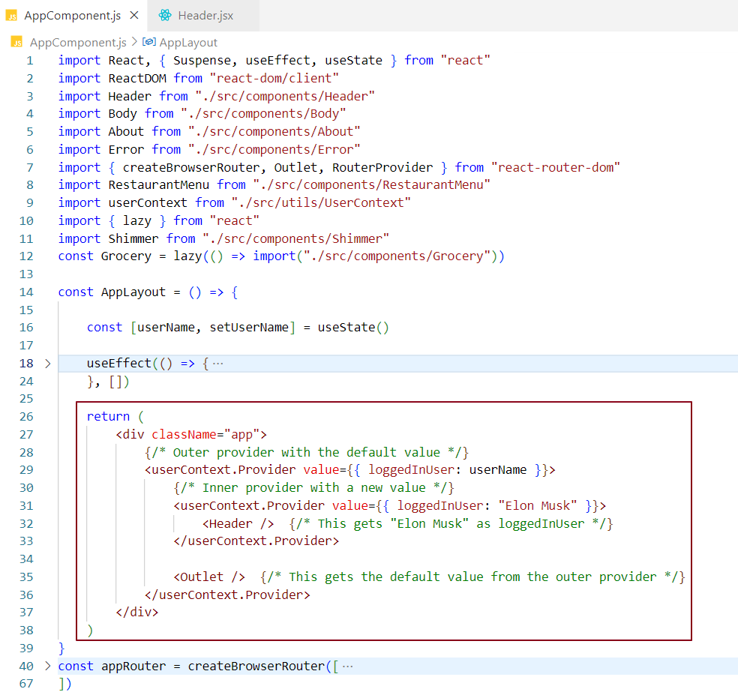

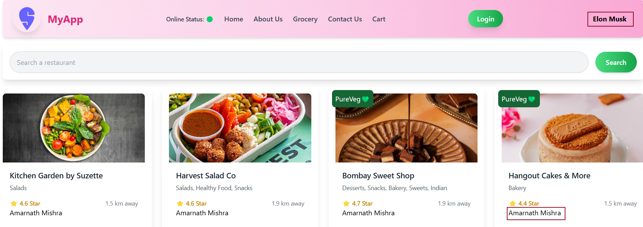

## Objective: Dynamically Change Context Data in React

We want to **create a textbox inside the** Body **component**. When the user types in the textbox, the **context data should update** dynamically, and this change should **reflect across all components** that consume the context.

## How to Achieve this ?

To enable dynamic updates to context data from a nested component like Body, follow these key points:

* ✅ The context data is **initially set in the** AppLayout component using useState.
* ✅ To allow the Body component to **modify the context data**, we need access to the **setter function** (setContextValue).
* ✅ To provide access for updating context data, we must include **both the current value and its setter function** in the context provider’s value prop.
* ✅ This allows the Body **component** to update the **context data via the textbox,** and whenever the context data changes**, all components that use this context will automatically re-render** with the updated value.

### **Steps to Implement**

Step 1 - In the **App**Component, define a function that updates the context data. In our setup we have defined a setter function setUserName.



Step 2 - Provide the function (setter) along with the context value to make it accessible in child components.

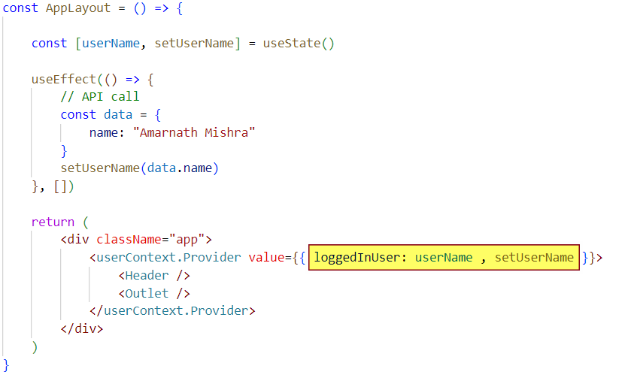

In the **Body** component, consume the context and use the setter function to update the data when the user types in the textbox.



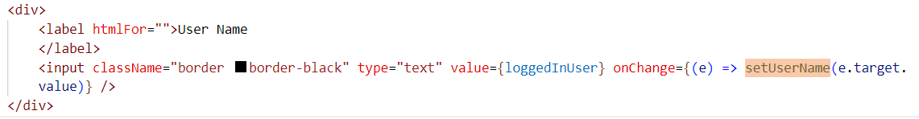

***AppComponent.jsx -***

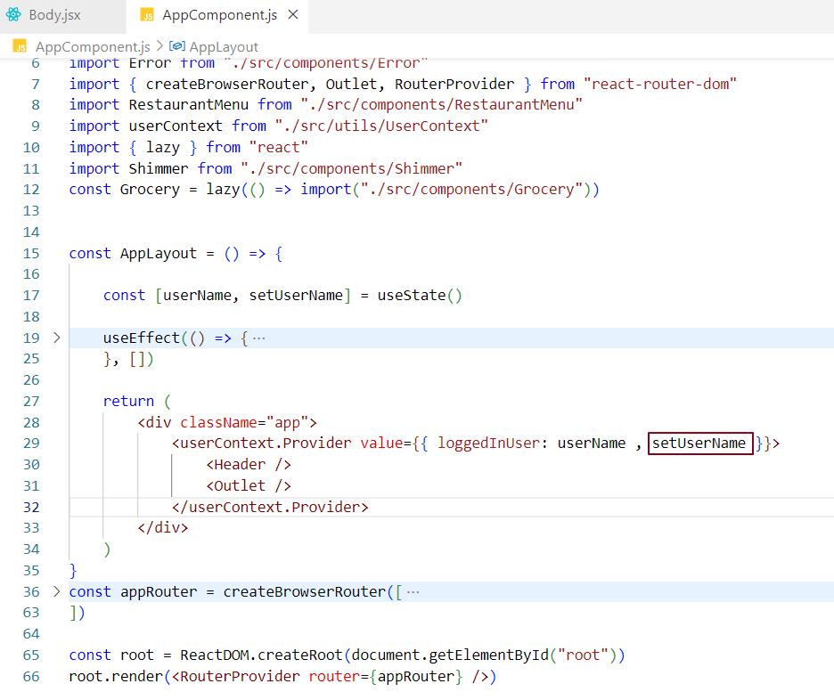

***Body.jsx -***

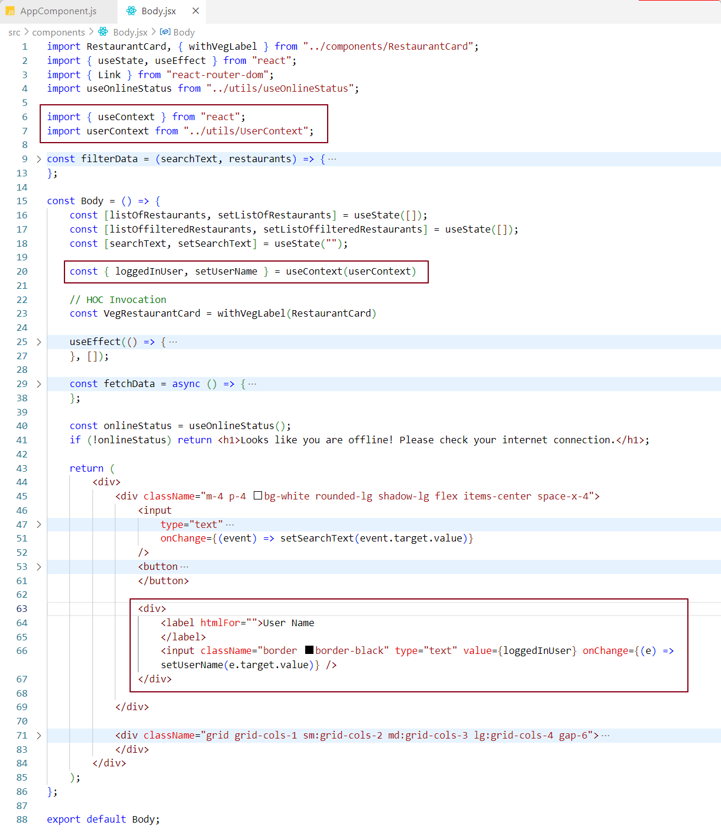

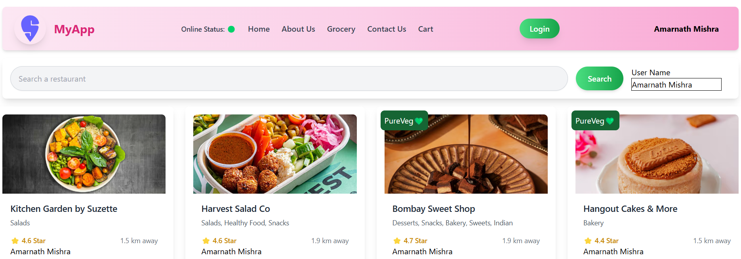

The moment you start typing in the **Username** textbox, you'll notice that **any component using this context data gets updated in real-time.**

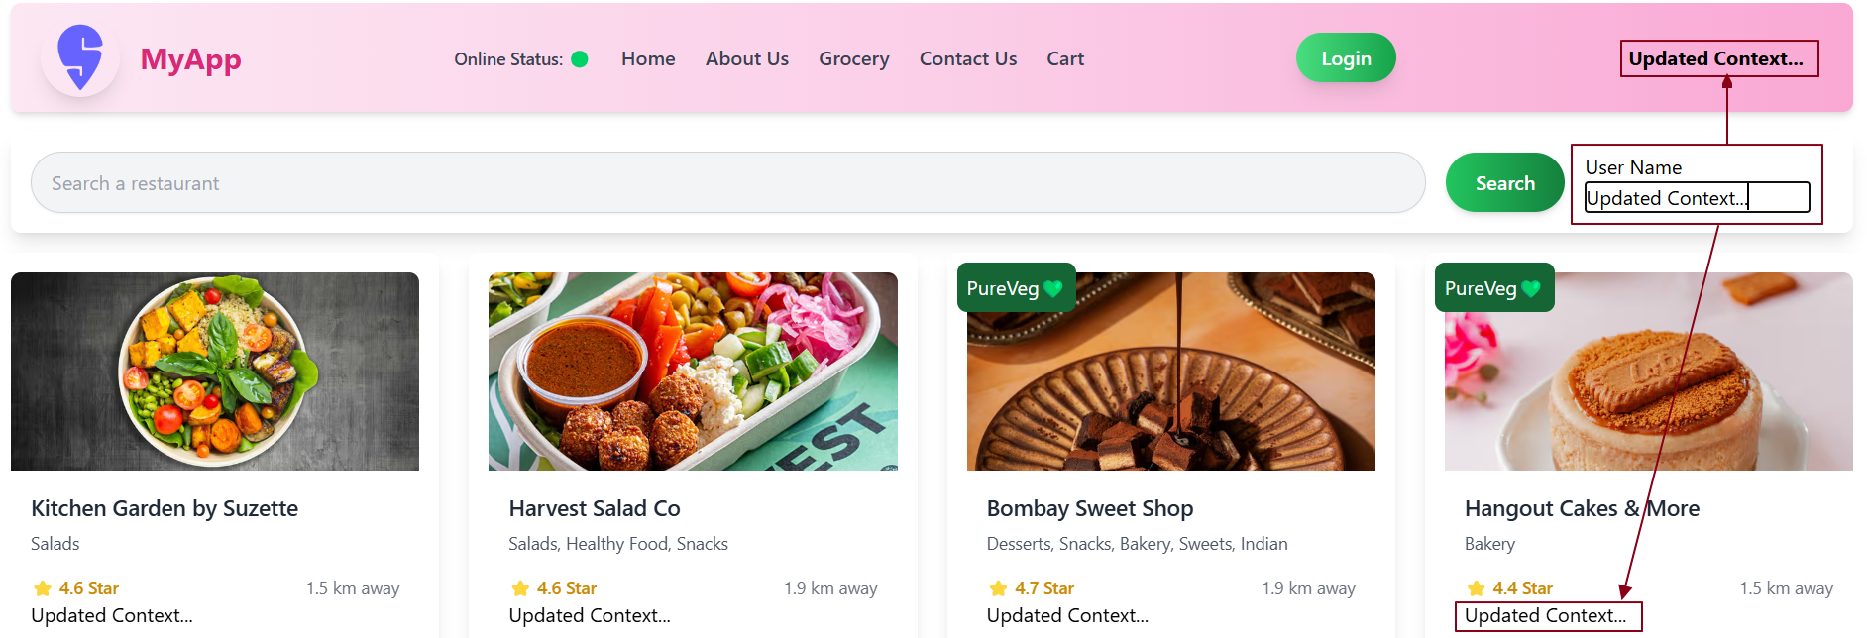

## 📌 **Effect of Context Changes on Lazily Loaded Components**

### *Scenario -*

* In our React application, the Grocery component is **lazily loaded** using techniques like React.lazy() and Suspense.
* Initially, when we are on the **home page**, the bundle for Grocery is **not loaded,** so its code isn’t part of the main bundle.
* While on the home page, a **context value** (e.g., username) is updated via a textbox.
* Later, when we navigate to the **Grocery** route, the component is loaded dynamically.

### *****What happens to the context value in this case?*****

Even though the Grocery component wasn't loaded at the time the context was updated, React Context ensures that all components consuming the context always receive the latest value. This applies regardless of when the component is rendered or lazily loaded. As a result, when the Grocery component is eventually lazily loaded, it will receive the most up-to-date context value.

***Lazy Loading -***

The Grocery component is lazily loaded using React.lazy(), which means:

* Its code is not included in the initial bundle and is only fetched when the user navigates to the Grocery route.
* This helps reduce the initial load time of the application, improving performance by loading only the necessary code upfront.

***Context Changes -***

➡️ The application is wrapped with userContext.Provider at the root level, which makes the context data (such as the loggedInUser state) available throughout the entire component tree including lazily loaded components like **Grocery**.

➡️ When the username is updated in the AppLayout via a textbox, the context state is updated globally. Because the provider is applied at the root, **any component that consumes the context—regardless of when or how it is loaded—will receive the latest context value upon rendering,** including those that are lazily loaded.

***How does It Work ?***

* When the **textbox** in **AppLayout** changes the username, the **context state** is updated immediately.
* **Even though the** Grocery **component’s code hasn’t been loaded yet** (because it’s lazily loaded), the context update still happens **immediately** and is accessible.
* When the user clicks on the **Grocery page**, react loads the Grocery component's code dynamically.
* By the time the Grocery component is rendered, the context data has already been updated, so Grocery **receives the updated value** even though it wasn't loaded when the username was changed.

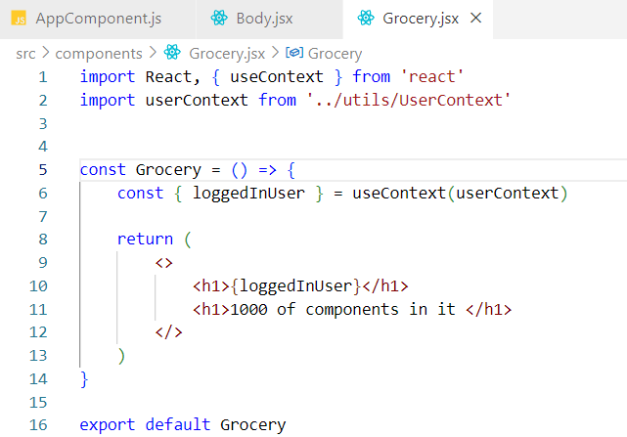

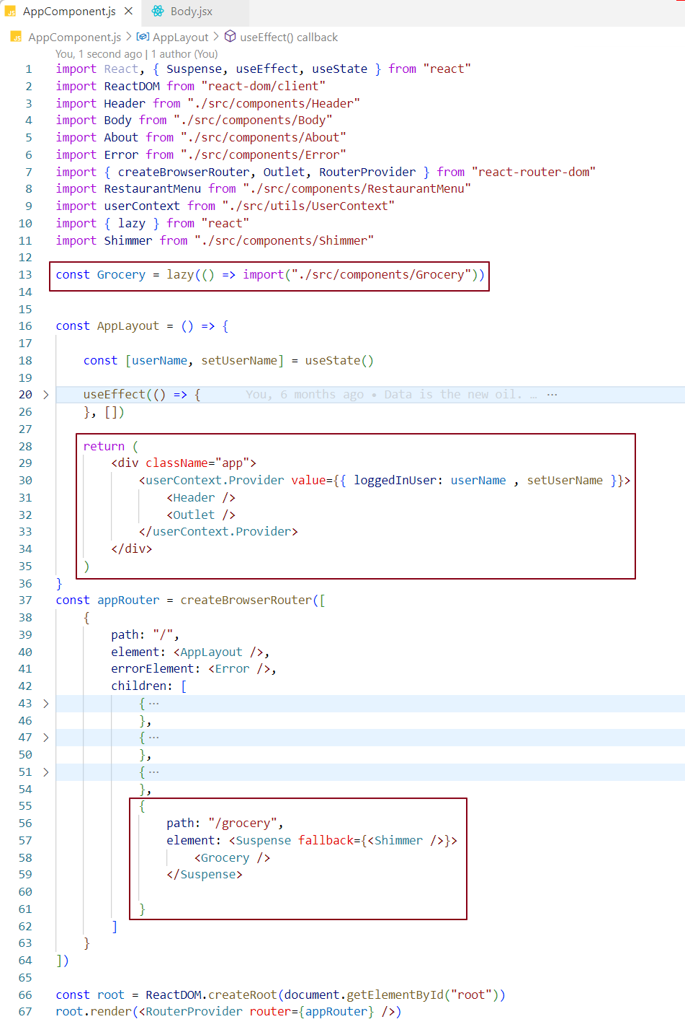

Any change in the context data from the **Body** component will also **automatically update** the lazily loaded components, such as the **Grocery** component.

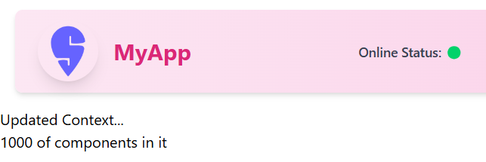

**Note** - React Context always delivers the latest context data to all components even lazily loaded ones. This ensures consistent state sharing across the app, regardless of when components are rendered or loaded.

### Difference Between **State** and **Props**:

***State:***  
State is used to store data that belongs to a single component and can change over time. For example, the value of a text input is stored in the state.

***Props:***  
Props are used to pass data from a parent component to a child component. They are read-only and cannot be modified by the child component.

***Note -*** While props are immutable within the child component, the parent component can update the props it passes by modifying its own state or handling events.

### How to Pass Data from Parent to Child Component ?

***Props*** are used to pass data from a parent to a child component. The parent component sends data to the child through props.

### How to Pass Data from Child to Parent Component ?

***Lifting State Up:*** The child component sends data to the parent by calling a function passed as a prop. The parent manages the state.

***Custom Hooks:*** Custom hooks can be created to share state and logic between components, enabling communication from the child to the parent.

### *Notes:*

***MyContext.Provider:*** The Provider component is used to pass down the value to all components within it.

***useContext(MyContext):*** The useContext hook allows you to access the context value inside any functional component.

Using Context in Class-Based Components -

***Step1 - create the context***

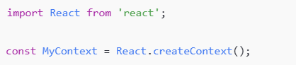

***Step 2 - Provide the Context in a Parent Component***

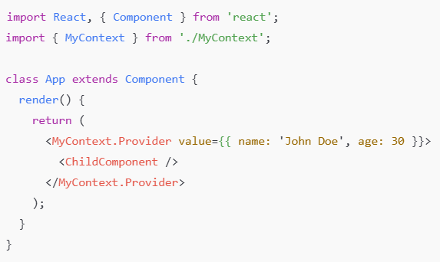

***Step 3 - Consume Context in the Class-Based Component***

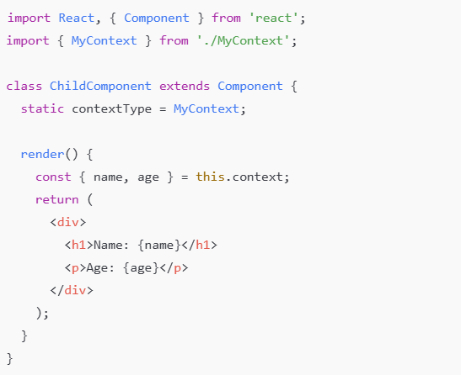

### *Explanation:*

* static contextType = MyContext;➡️ This links the class component to the context.
* this.context➡️ Access the context values within the class component after setting contextType.

***Alternative way to consume a context using Context.Consumer –***

**What is** Context.Consumer **in React?**

* Context.Consumer is a React component provided by the Context API.
* It allows a component to access context values directly, without prop drilling.
* It can be used in any component (class or functional).
* It is especially useful in class components where useContext (a hook) can't be used.
* It works by using the **render prop pattern** — i.e., passing a **function as a child**.
* React calls this function with the current context value whenever it changes.
* **Components using** Context.Consumer **automatically subscribe to the context,** and re-render whenever the context value updates.

## When do you use it?

* In **class components** that **don’t use** contextType.
* In **functional components before Hooks (**useContext**) existed.**
* When you need to **consume multiple contexts together.**

## How does it work?

* It **expects a function** as a child (called a **render prop**).
* That function receives the **current context value** as its argument.
* You **return JSX** from that function using the context value.
* **Whenever the context changes**, the function **re-runs**, causing a re-render.

**Note -**

In React, anything placed **between JSX tags** (like inside <Context.Consumer>{...}</Context.Consumer>) is considered a **child,** and if that child is a function, react treats it as a **render prop** — a special pattern where the function gets context data and returns JSX.

**Syntax -**

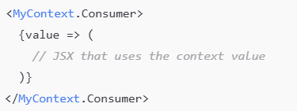

✅ This pattern works in both **class** and **function** components.

🔄 Visual Flow

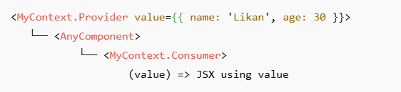

***Using Context.Consumer in functional component -***

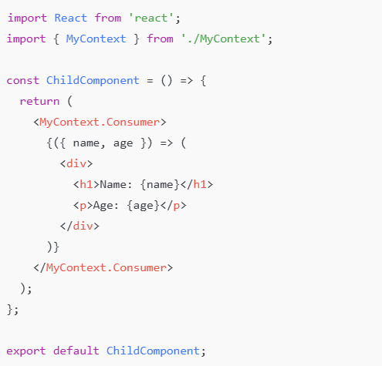

***Using Context.Consumer in class-based component -***

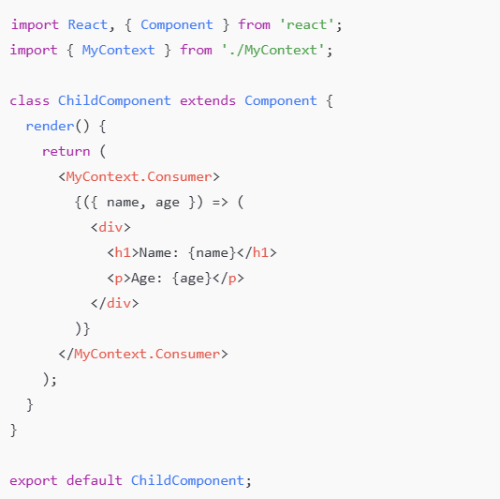

Using Multiple Contexts in a Single Component

### It means you want to access multiple context values in the same component. In functional components, you can call useContext() multiple times — one for each context. But in class components, where hooks aren't available, you achieve this by nesting multiple Context.Consumer components.

### Example:

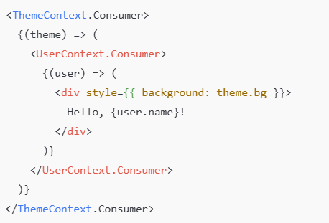

* Here, you're **nesting consumers** to get values from both ThemeContext and UserContext.
* This was the **standard approach** before hooks like useContext.